David Willis

Lingma Acheson

CIT 30400

4.23.2018

Final Presentation

**Items 1, 2, & 4**

**Item 1 – Create code blocks to process data. Variables and loops must be used.**

**Item 2 – Create code blocks to retrieve record sets from tables in your database. Cursors must be used.**

**Item 4 – have at least two triggers in database to keep track of different types of activities (one for insertion and one for deletion)**

--Create a table to insert values into later on

--The function of this upcoming code block is to find find all anime

--from the RANK_PROJECT table and add a column that rates the anime as 'masterpiece anime' (if score > 9),

--'great anime' (if score > 8 and score < 9), 'good anime' (if score > 7 an d score < 8, or 'bad anime' ( if score < 7 )

--Although, there is only 250 rows of anime, so there will not be any anime with a score of less than 7

--This is a quick way for a person to skim through the list and generally find which anime would be worth watching or not (based on popularity of course)

CREATE TABLE MASTERPIECE_ANIME (

mast_anime_id varchar2(10), --create variables and their data types

mast_members_voted number,

mast_ranked number,

mast_score number,

mast_word_rating varchar2(40)

);

--Item 4

--Create this table for the trigger to log new inserts into the MASTERPIECE_ANIME table

--by placing these log updates into the MASTERPIECE_ANIME_LOG table

--This would be useful for keeping a log of all the inserts into a particular table

--This could be used to delete information that ought not be in a certain table

--This could be used to track when the update happened and which user made the update happen

CREATE TABLE MASTERPIECE_ANIME_LOG (

log_anime_id varchar2(10), --create variables and their data types

log_members_voted number,

log_ranked number,

log_score number,

log_word_rating varchar2(40),

log_user varchar2(40),

log_sysdate date

);

--Code block begins here

--Use Declare block to declare variables and their data types to insert values into during the loop later on

DECLARE

v_anime_id RANK_PROJECT.anime_id%TYPE; --create variable to insert values from loop into, but referencing RANK_PROJECT table because that is where the data will be pulled from

v_members_voted RANK_PROJECT.members_voted%TYPE;

v_ranked RANK_PROJECT.ranked%TYPE;

v_score RANK_PROJECT.score%TYPE;

--Cursor begins here

--Cursor allows user to assign a name to a SELECT statement and manipulate the information

--Create c_anime cursor variable that holds the contents of the RANK_PROJECT table

CURSOR c_anime IS

SELECT anime_id, members_voted, ranked, score

FROM RANK_PROJECT;

--create word_rating variable to store strings 'masterpiece anime' and so on

word_rating varchar2(40);

--BEGIN statement will allow the use of opening cursors and using loops

--The statements that manipulate the variables created above can be done within the begin block

BEGIN

--Open the c_anime cursor created earlier

--Allows for the use of the previously created variable

OPEN c_anime;

--Begin loop

--By using the loop, able to fetch each row and put it into the new table

--Loop goes row by row, traversing through each data variable

LOOP

--Fetch statement below grabs the variable created above that references the RANK_PROJECT TABLE and places these variables row by row (as loop occurs) into c_anime cursor

--Exit statement stops the loop when there are no more rows of data to sift through

FETCH c_anime INTO v_anime_id, v_members_voted, v_ranked, v_score;

EXIT when c_anime%NOTFOUND;

--If the score is greater than 9, then update the word_rating variable to 'masterpiece_anime'

--Then insert all of the values from the fetch statement and the newly updated word_rating value into the MASTERPIECE_ANIME TABLE

IF v_score > 9 THEN

word_rating := 'MASTERPIECE ANIME';

INSERT INTO MASTERPIECE_ANIME VALUES(v_anime_id, v_members_voted, v_ranked, v_score, word_rating);

--Else if score is greater than 8 and less than 9, then update the word_rating variable to 'masterpiece_anime'

ELSIF v_score > 8 AND v_score < 9 THEN

word_rating := 'GREAT ANIME';

INSERT INTO MASTERPIECE_ANIME VALUES(v_anime_id, v_members_voted, v_ranked, v_score, word_rating);

--Else if score is greater than 7 and less than 8, then update the word_rating variable to 'great anime'

ELSIF v_score > 7 AND v_score < 8 THEN

word_rating := 'GOOD ANIME';

INSERT INTO MASTERPIECE_ANIME VALUES(v_anime_id, v_members_voted, v_ranked, v_score, word_rating);

--Else if score is less than 7, then it is just a bad anime and the column will say 'bad anime'

ELSE

INSERT INTO MASTERPIECE_ANIME VALUES(v_anime_id, v_members_voted, v_ranked, v_score, 'BAD ANIME');

--Must end if statements to avoid errors

END IF;

--Must end loop and close c_anime cursor as well

END LOOP;

CLOSE c_anime;

--Designates the end of the code block

END;

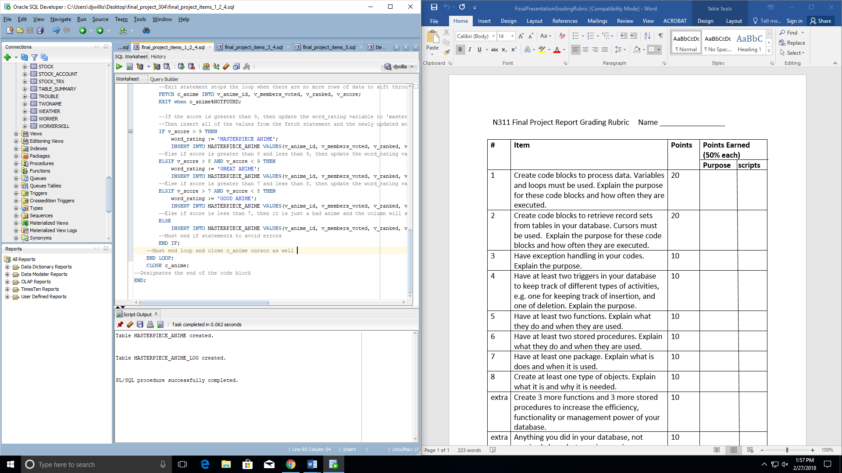

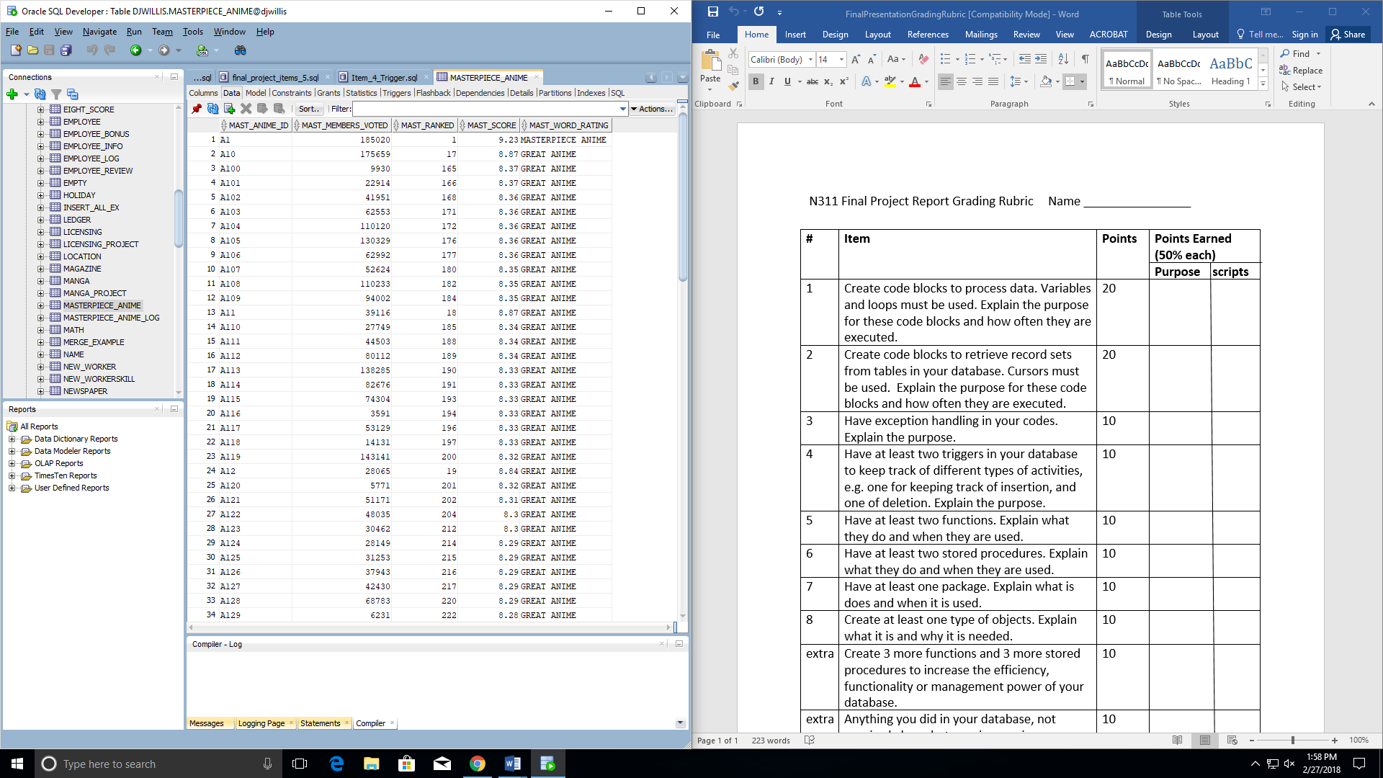

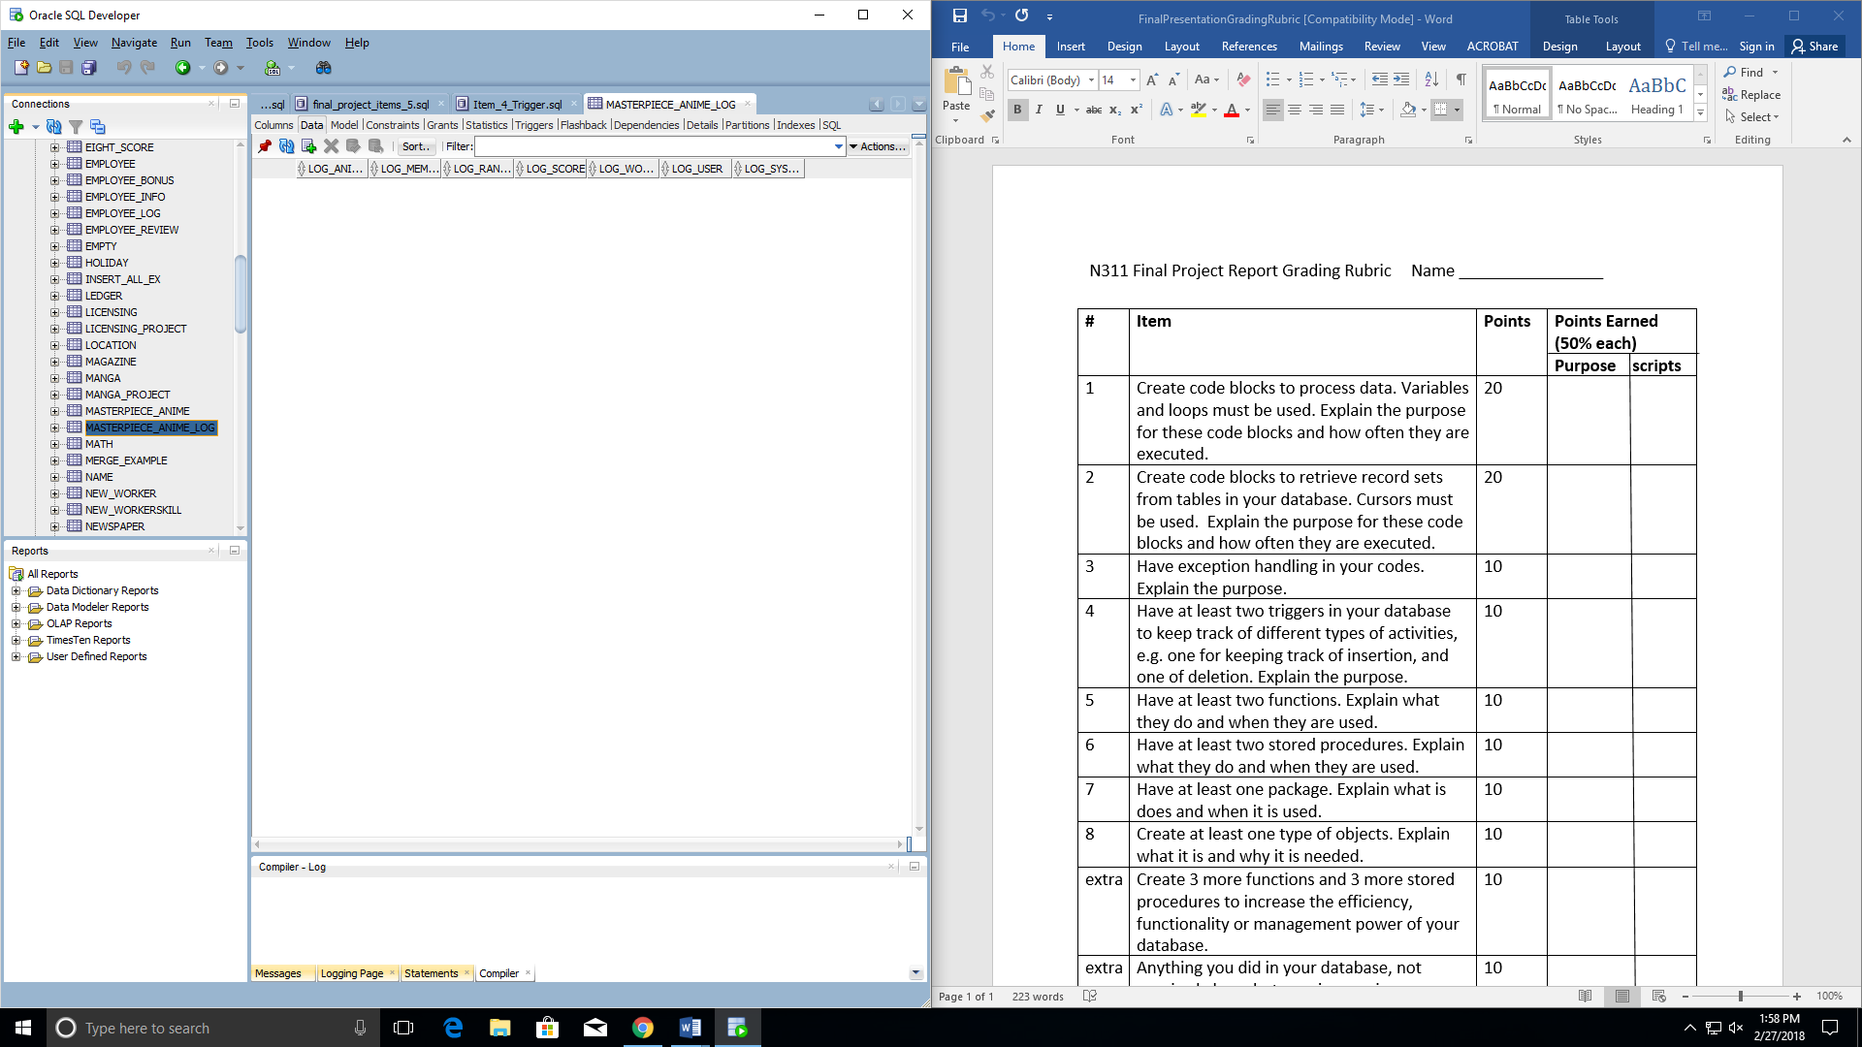

**Proof that the trigger works (tracking insertion):**

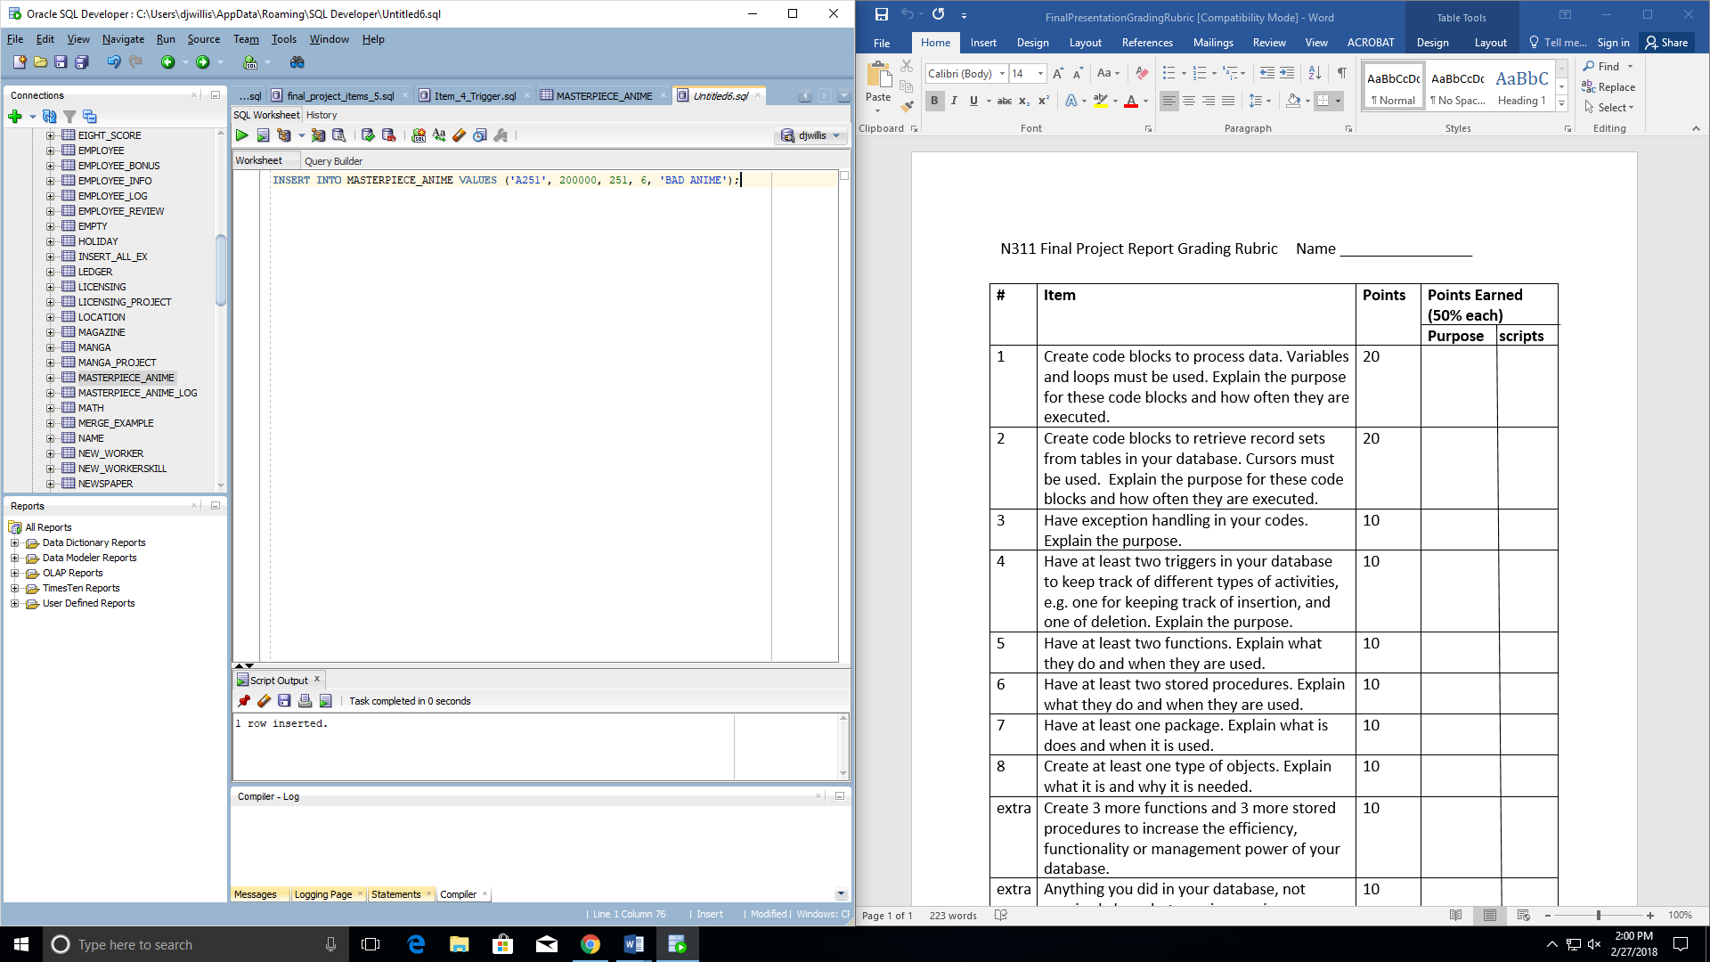

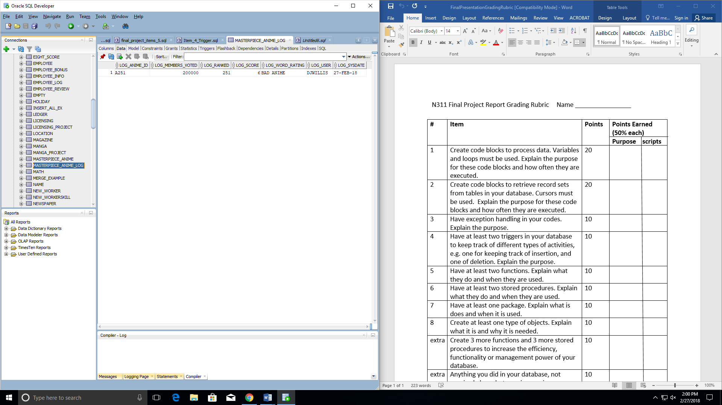

--Item 4, Have at least two triggers in your database to keep track of different

--types of activities

--Trigger #1

--This trigger keeps track of new entries added to the MASTERPIECE_ANIME table

--The new entries will be placed into the MASTERPIECE_ANIME_LOG table

create or replace TRIGGER MASTERPIECE_ANIME_TRIGGER

AFTER INSERT ON MASTERPIECE_ANIME

FOR EACH ROW

BEGIN

INSERT INTO MASTERPIECE_ANIME_LOG VALUES (:new.mast_anime_id, :new.mast_members_voted, :new.mast_ranked,

:new.mast_score, :new.mast_word_rating, user, Sysdate);

END;

Proof that the trigger worked:

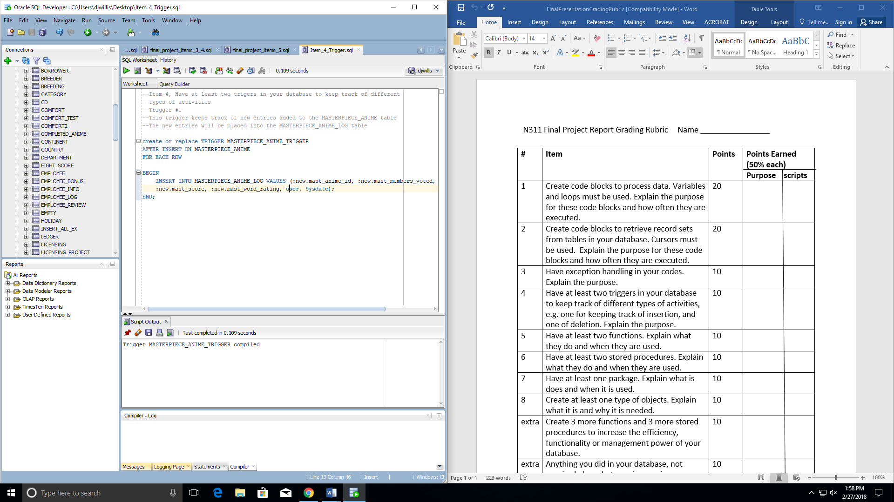

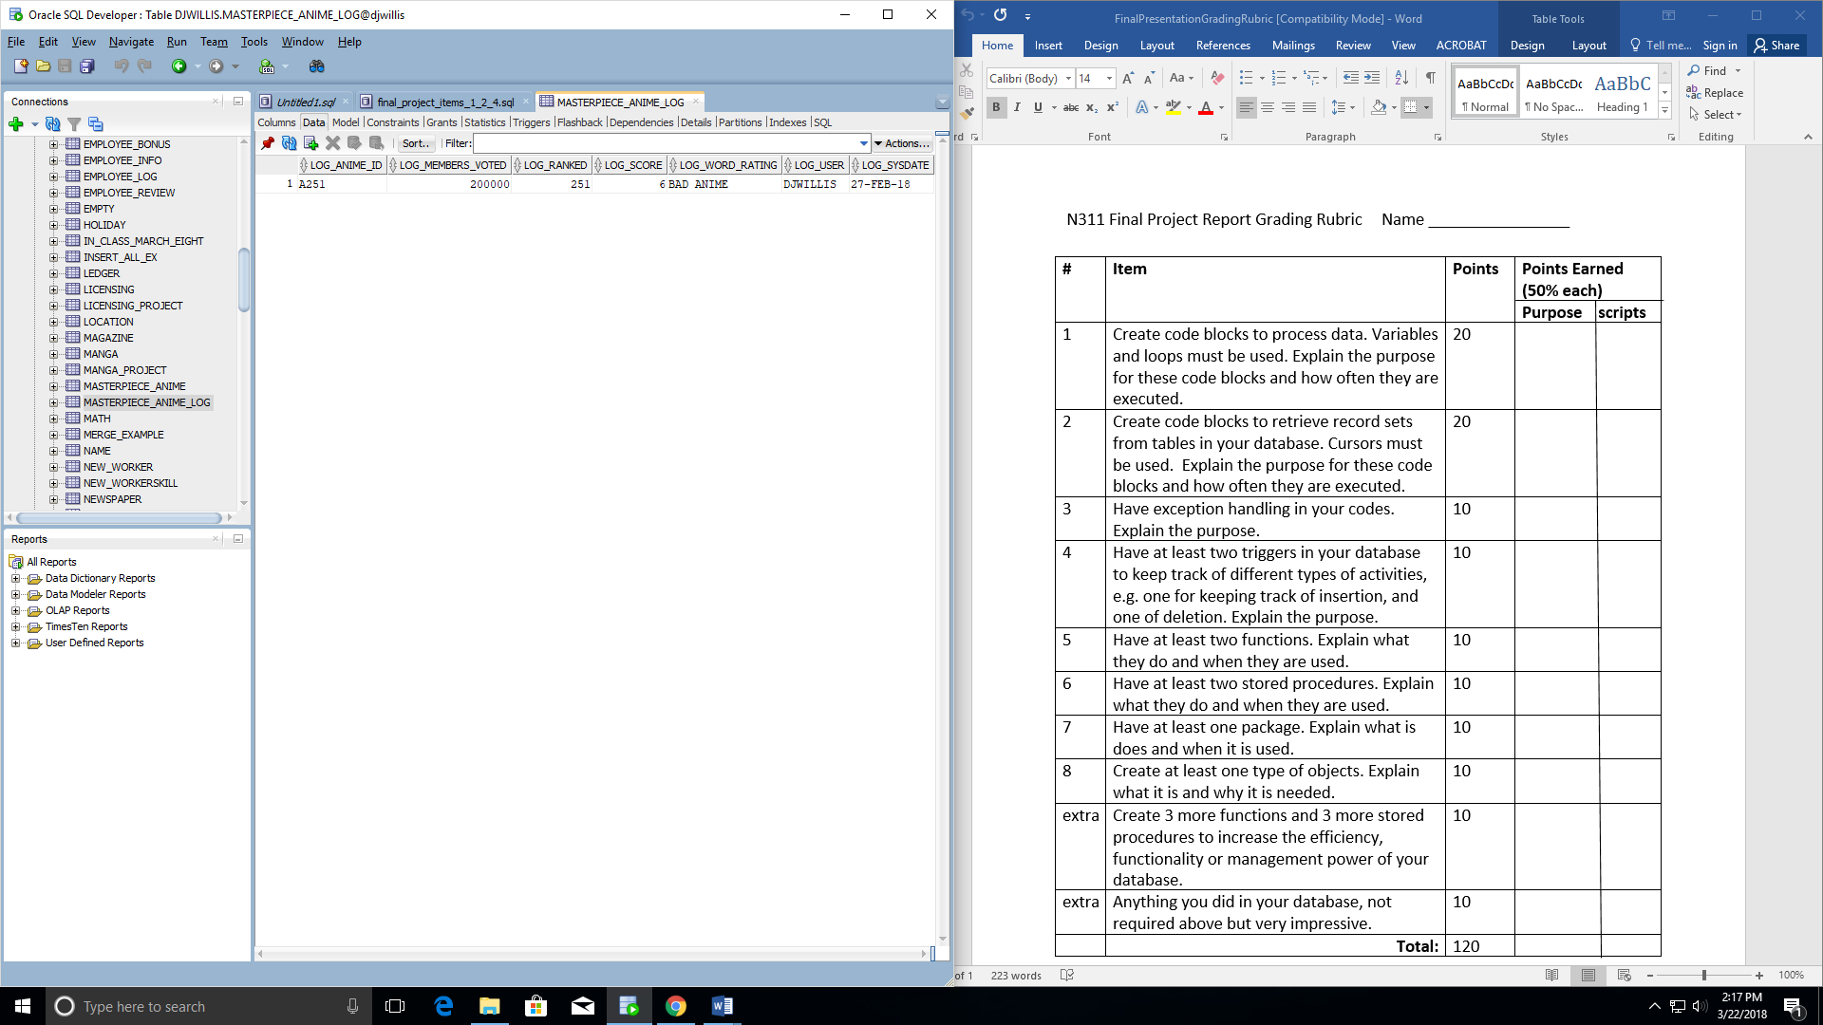

--Item 4

--Trigger #2

--This trigger keeps track of the new entries added to the COMPLETED_ANIME table

--The new entries will be placed into the COMPLETED_ANIME_LOG table

create or replace TRIGGER COMPLETED_ANIME_TRIGGER

AFTER INSERT ON COMPLETED_ANIME

FOR EACH ROW

BEGIN

INSERT INTO COMPLETED_ANIME_LOG VALUES (:new.comp_anime_id, :new.comp_title, :new.comp_anime_status,

:new.comp_main_genre, :new.comp_rating, :new.comp_manga_id, user, Sysdate);

END;

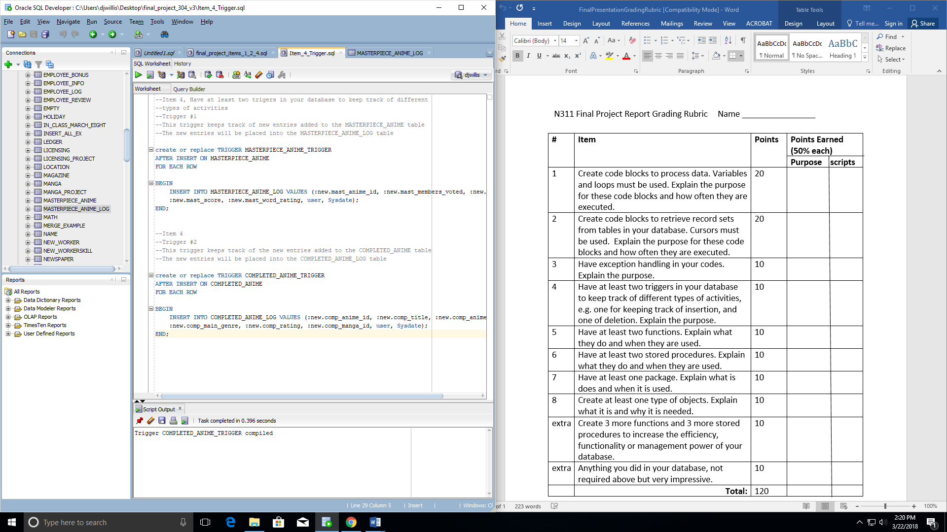

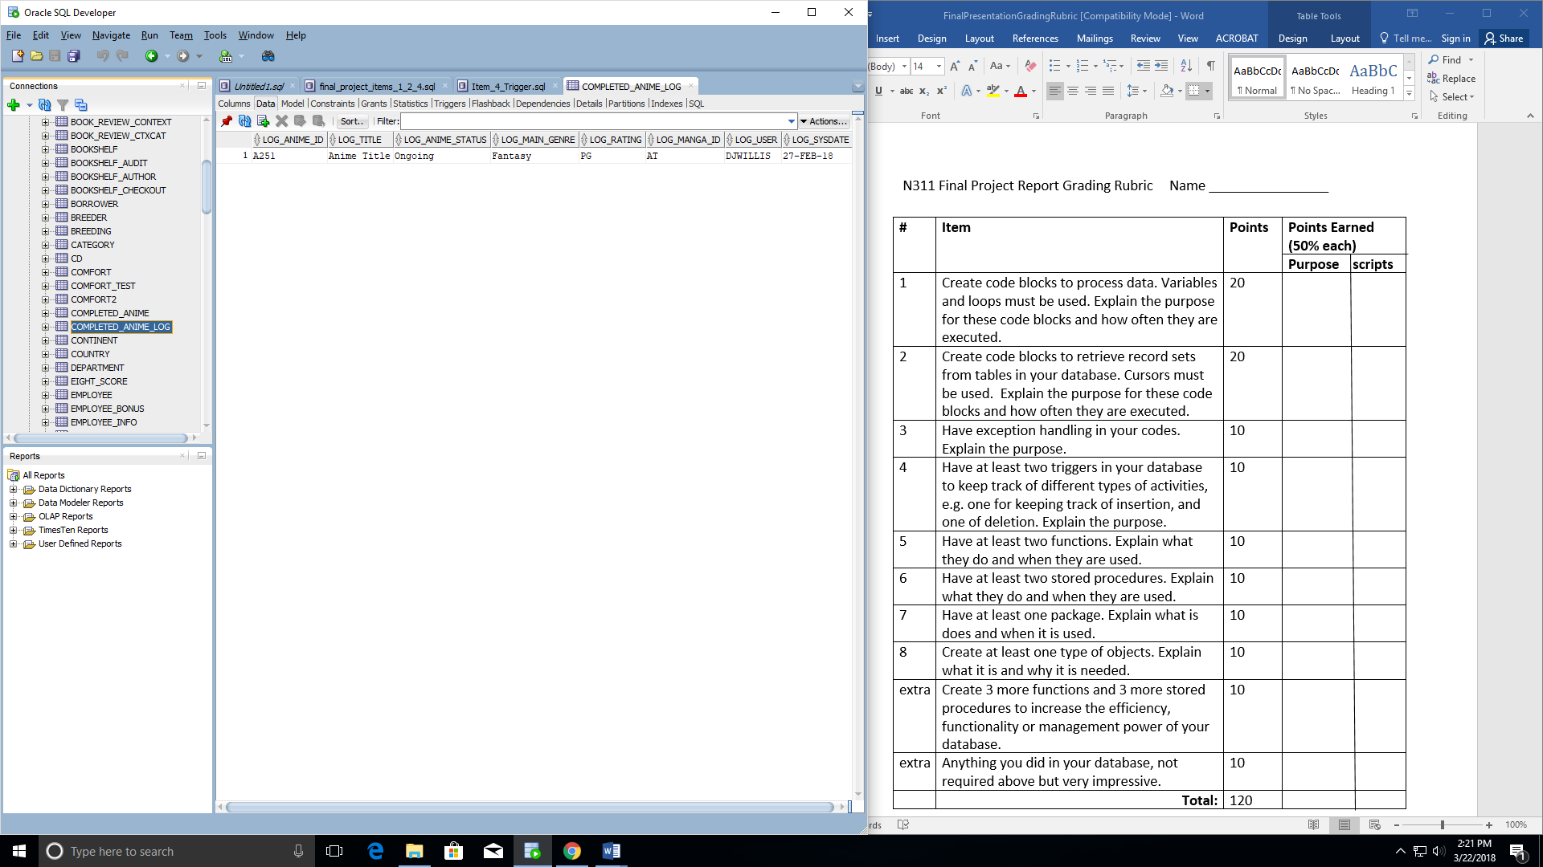

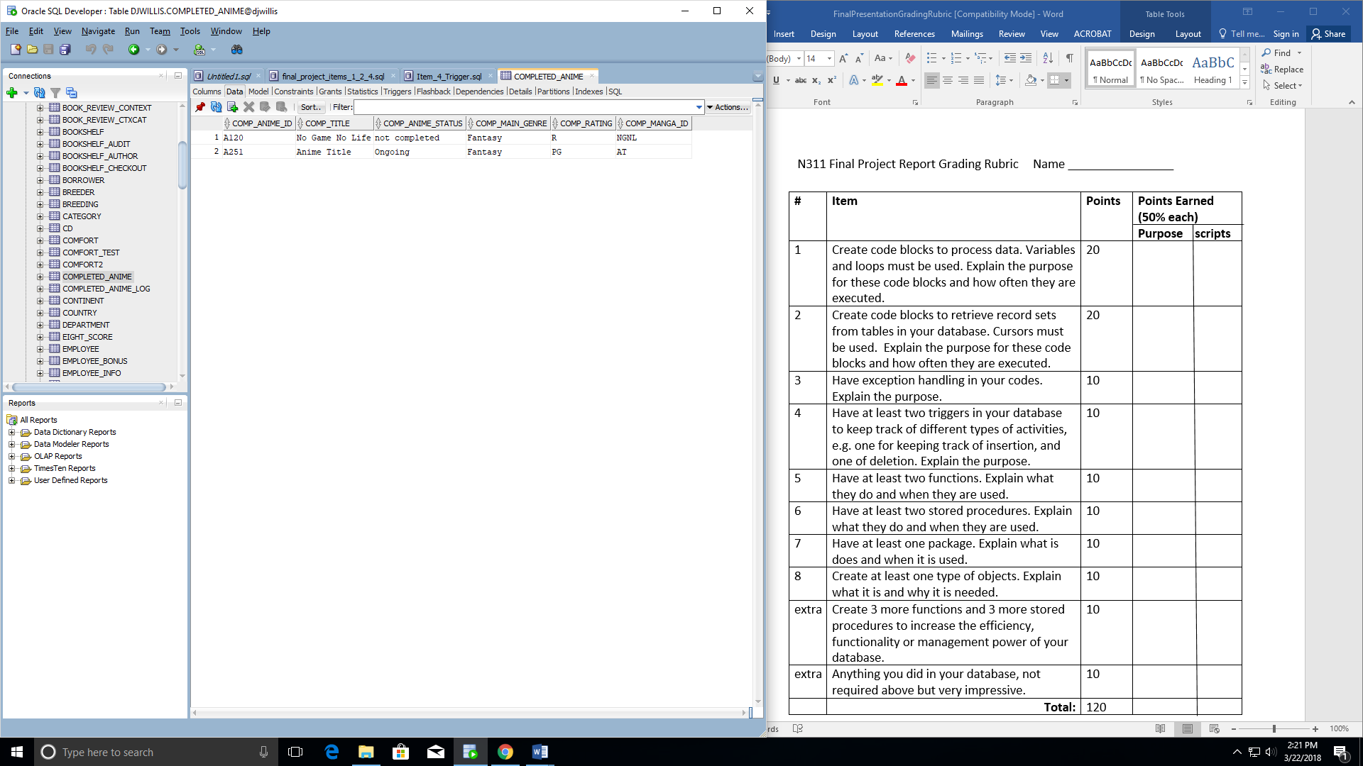

Items 3 & 4

**Item 3 – Have exception handling in your codes**

**Item 4 – Use Triggers**

--Item 3

--Create a table to insert values into later on

--The function of this upcoming code block is to find find all anime

--from the RANK_PROJECT table and add a column that rates the anime as 'masterpiece anime' (if score > 9),

--'great anime' (if score > 8 and score < 9), 'good anime' (if score > 7 an d score < 8, or 'bad anime' ( if score < 7 )

--Although, there is only 250 rows of anime, so there will not be any anime with a score of less than 7

--This is a quick way for a person to skim through the list and generally find which anime would be worth watching or not (based on popularity of course)

CREATE TABLE COMPLETED_ANIME (

comp_anime_id varchar2(10), --create variables and their data types

comp_title varchar2(80),

comp_anime_status varchar2(40),

comp_main_genre varchar2(40),

comp_rating varchar2(10),

comp_manga_id varchar2(10)

);

--Item 4

--Create this table for the trigger to log new inserts into the MASTERPIECE_ANIME table

--by placing these log updates into the MASTERPIECE_ANIME_LOG table

--This would be useful for keeping a log of all the inserts into a particular table

--This could be used to delete information that ought not be in a certain table

--This could be used to track when the update happened and which user made the update happen

CREATE TABLE COMPLETED_ANIME_LOG (

log_anime_id varchar2(10), --create variables and their data types

log_title varchar2(80),

log_anime_status varchar2(40),

log_main_genre varchar2(40),

log_rating varchar2(10),

log_manga_id varchar2(10),

log_user varchar2(40),

log_sysdate varchar2(40)

);

--Code block begins here

--Use Declare block to declare variables and their data types to insert values into during the loop later on

DECLARE

v_anime_id ANIME_PROJECT.anime_id%TYPE; --create variable to insert values from loop into, but referencing RANK_PROJECT table because that is where the data will be pulled from

v_title ANIME_PROJECT.title%TYPE;

v_anime_status ANIME_PROJECT.anime_status%TYPE;

v_main_genre ANIME_PROJECT.main_genre%TYPE;

v_rating ANIME_PROJECT.rating%TYPE;

v_manga_id ANIME_PROJECT.manga_id%TYPE;

--Cursor begins here

--Cursor allows user to assign a name to a SELECT statement and manipulate the information

--Create c_anime cursor variable that holds the contents of the RANK_PROJECT table

CURSOR c_anime_comp IS

SELECT anime_id, title, anime_status, main_genre, rating, manga_id

FROM ANIME_PROJECT;

not_completed EXCEPTION;

--BEGIN statement will allow the use of opening cursors and using loops

--The statements that manipulate the variables created above can be done within the begin block

BEGIN

--Open the c_anime cursor created earlier

--Allows for the use of the previously created variable

OPEN c_anime_comp;

--Begin loop

--By using the loop, able to fetch each row and put it into the new table

--Loop goes row by row, traversing through each data variable

LOOP

--Fetch statement below grabs the variable created above that references the RANK_PROJECT TABLE and places these variables row by row (as loop occurs) into c_anime cursor

--Exit statement stops the loop when there are no more rows of data to sift through

FETCH c_anime_comp INTO v_anime_id, v_title, v_anime_status, v_main_genre, v_rating, v_manga_id;

EXIT when c_anime_comp%NOTFOUND;

--If the score is greater than 9, then update the word_rating variable to 'masterpiece_anime'

--Then insert all of the values from the fetch statement and the newly updated word_rating value into the MASTERPIECE_ANIME TABLE

IF v_anime_status = 'Ongoing' THEN

RAISE not_completed;

END IF;

--Must end loop and close c_anime cursor as well

END LOOP;

CLOSE c_anime_comp;

EXCEPTION

WHEN not_completed THEN

INSERT INTO COMPLETED_ANIME VALUES(v_anime_id, v_title, 'not completed', v_main_genre, v_rating, v_manga_id);

--Designates the end of the code block

END;

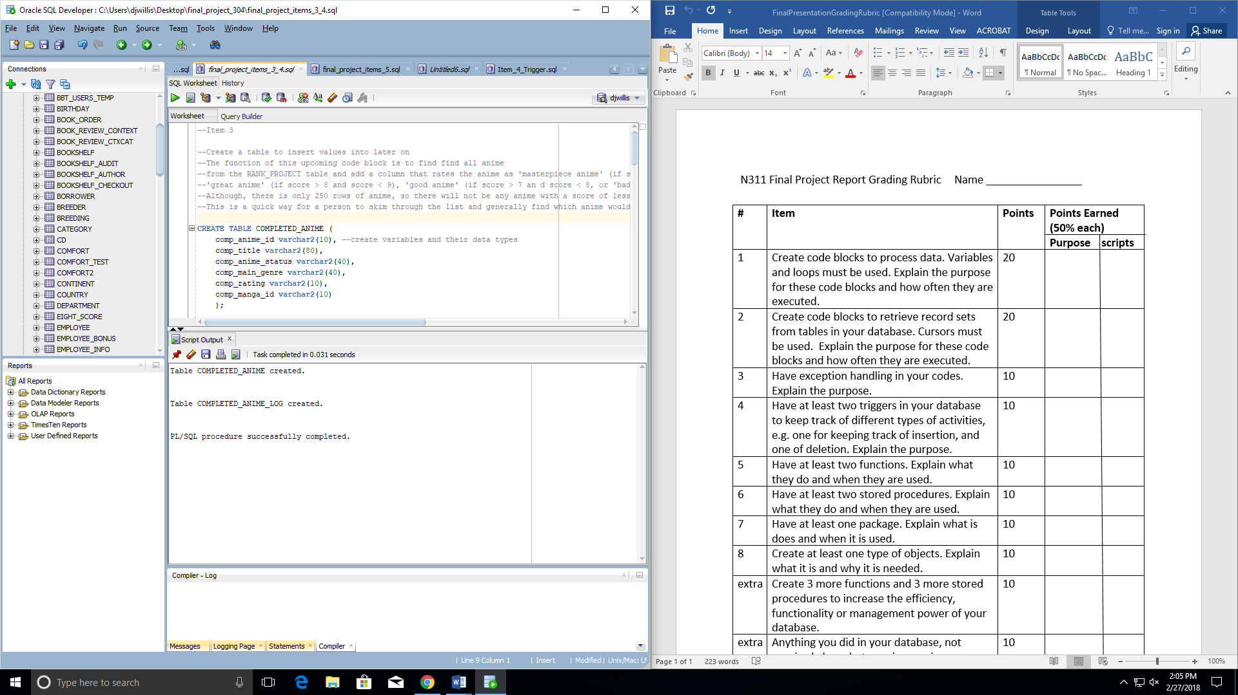

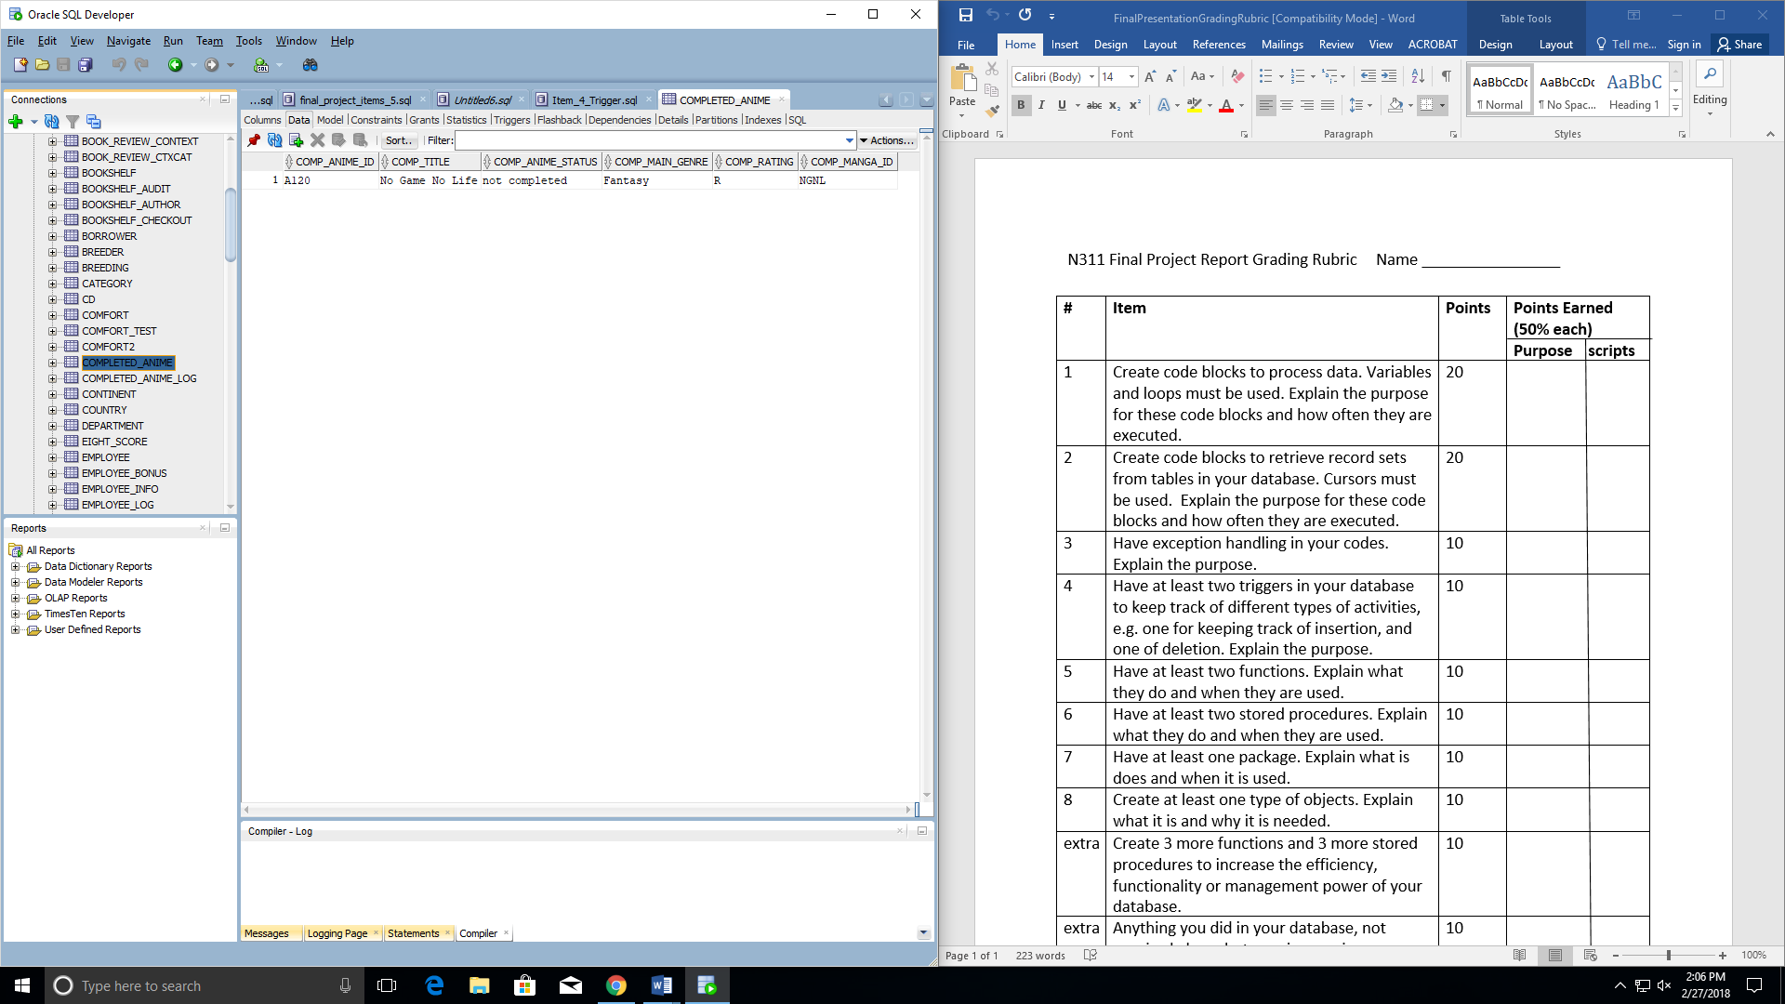

--Item 4

--Trigger #2

--This trigger keeps track of the new entries added to the COMPLETED_ANIME table

--The new entries will be placed into the COMPLETED_ANIME_LOG table

create or replace TRIGGER COMPLETED_ANIME_TRIGGER

AFTER INSERT ON COMPLETED_ANIME

FOR EACH ROW

BEGIN

INSERT INTO COMPLETED_ANIME_LOG VALUES (:new.comp_anime_id, :new.comp_title, :new.comp_anime_status,

:new.comp_main_genre, :new.comp_rating, :new.comp_manga_id, user, Sysdate);

END;

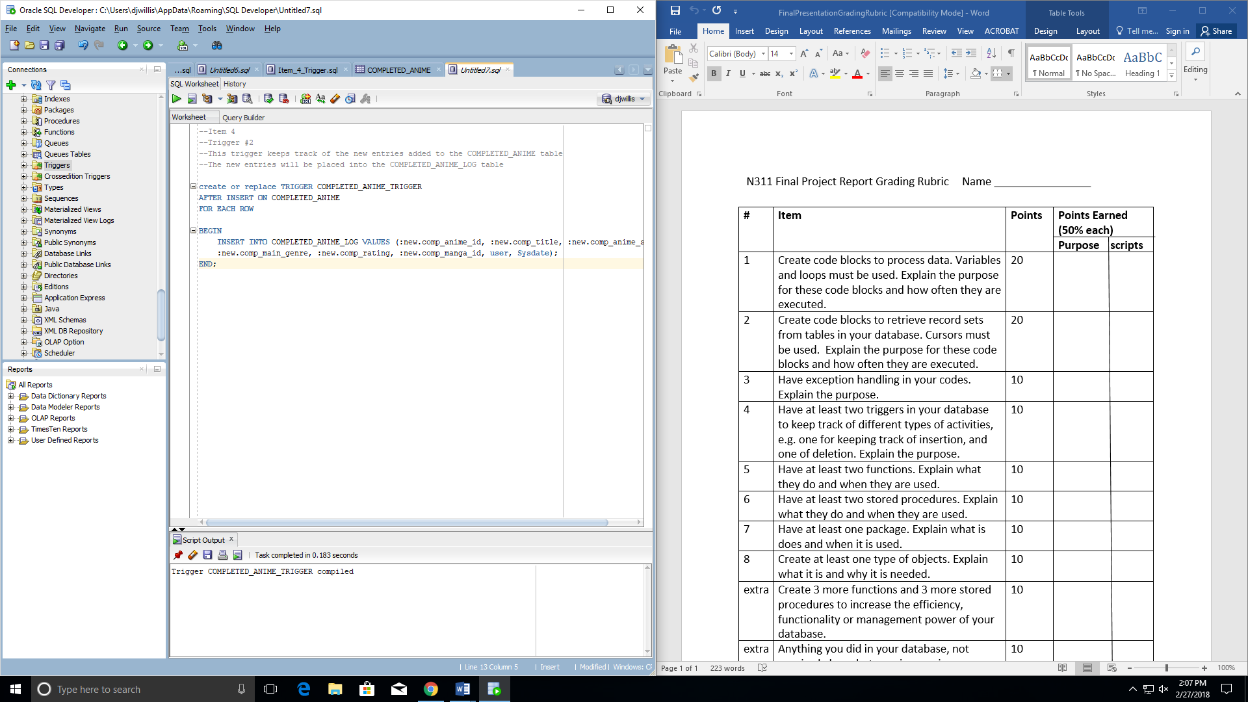

**Proof that the trigger works:**

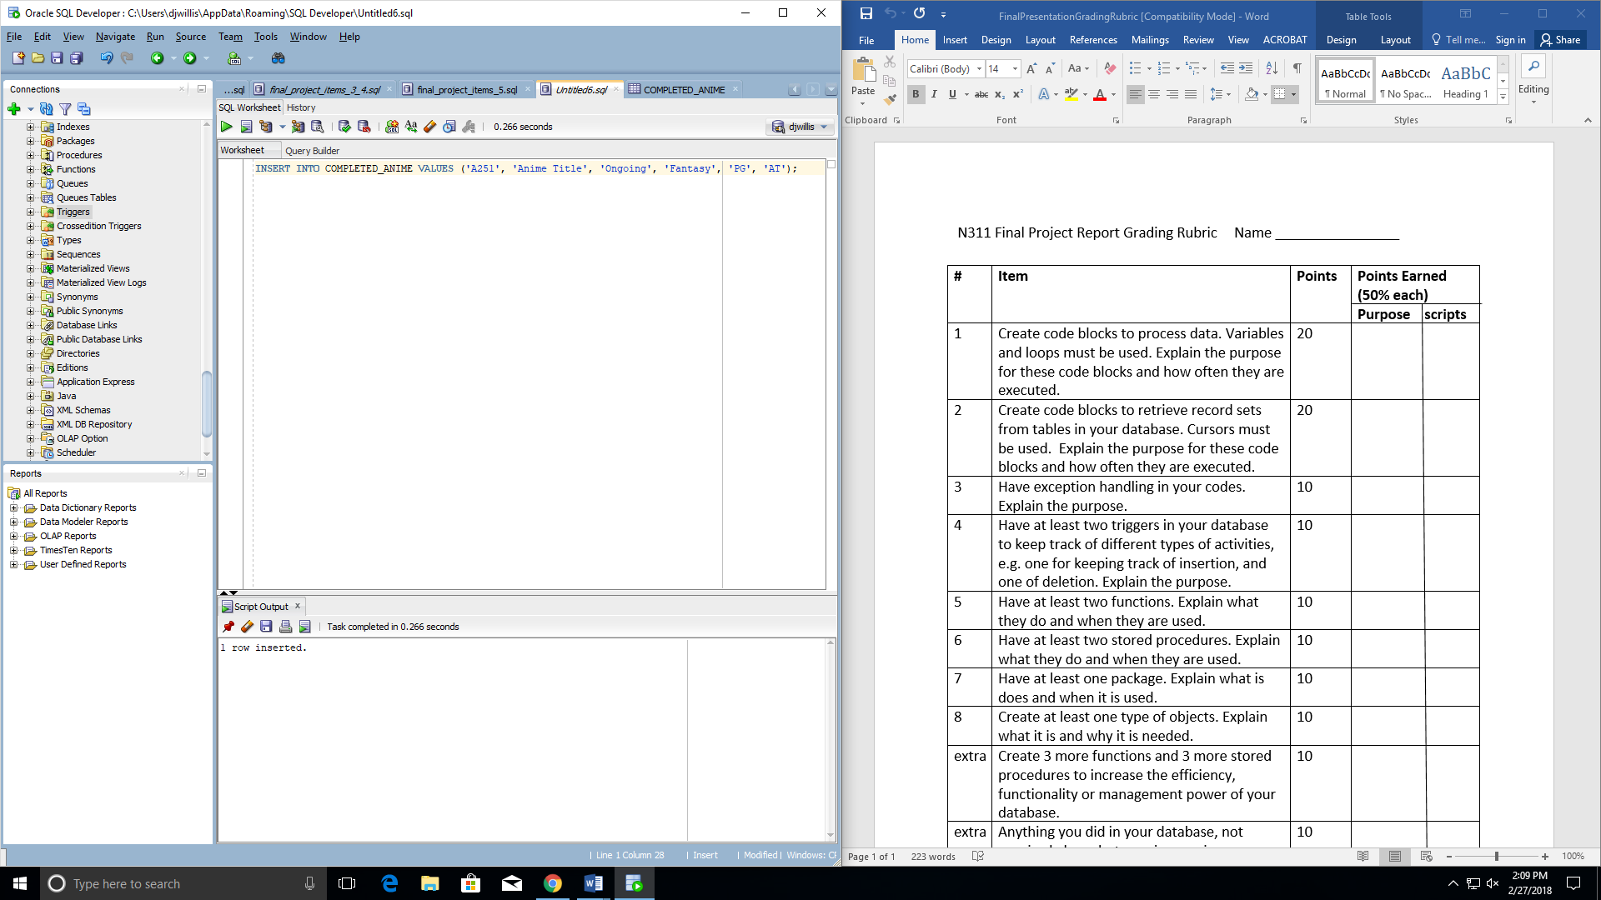

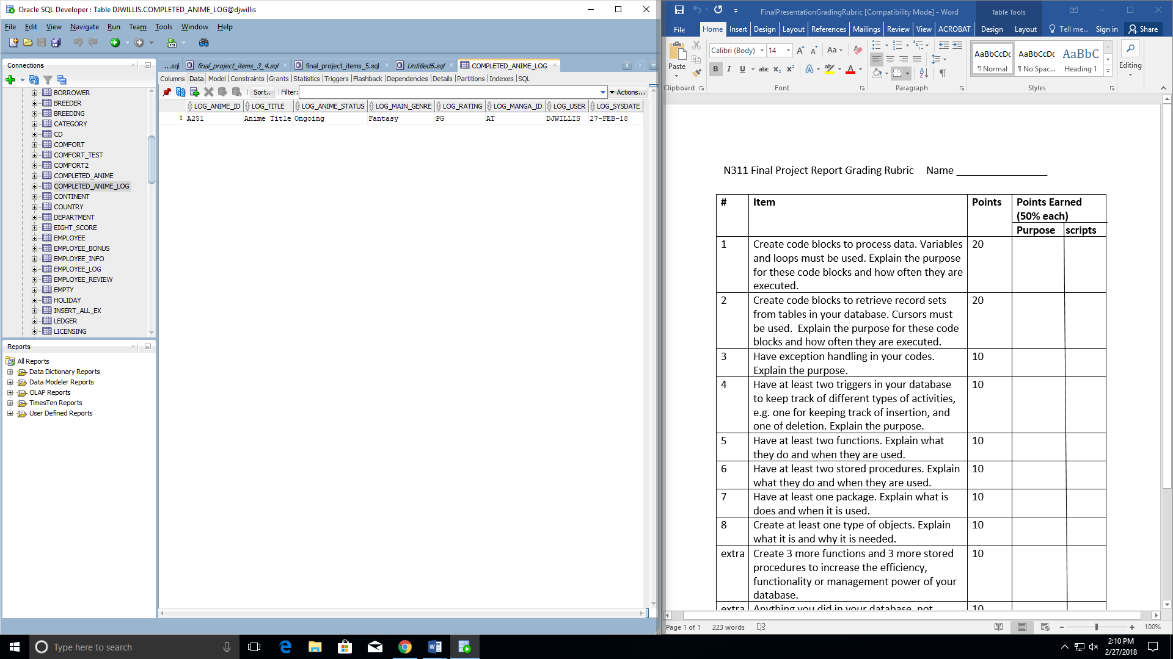

**--Item 5, Have at least two functions. Explain what they do and when they are used**

**--1st Function**

**set serveroutput on**

**--Create function named "total_anime"**

**--This function will return a number to the end user**

**CREATE OR REPLACE FUNCTION total_anime**

**RETURN number IS**

**--initialize the total number variable to be returned at the end of calling function**

**total number(3) := 0;**

**BEGIN**

**--select a count of all rows from the ANIME_PROJECT table into the total variable**

**SELECT count(*) into total**

**FROM ANIME_PROJECT;**

**RETURN total;**

**END;**

**/ --returns the total number of anime listed in the database**

**--Call the function using a code block, which is part of item 2 in rubric**

**DECLARE**

**--declare total_anime variable which will hold the returned number from the 1st function**

**totals number;**

**BEGIN**

**--set total_anime variable equal to the returned number from the 1st function**

**totals := total_anime();**

**--output the total number of anime in database to console log**

**dbms_output.put_line('Total no. of anime in database: ' || totals);**

**END;**

**/**

**--2nd function**

**--Compare two manga series together and find which one has the most chapters of the two**

**--Plus the winner's total chapters and how many more chapters it has over the other**

**--Declare and initialize the variables we will use for the function**

**DECLARE**

**--holds randomly selected manga with its total chapters thus far**

**manga_a number;**

**--holds randomly selected manga with its total chapters thus far**

**manga_b number;**

**--will hold the number result from the findMax function (comparing total manga chapters between the two selected manga series**

**manga_max number;**

**--the manga that has the most chapters will be stored into this variable**

**manga_1 varchar2(80);**

**--chapter_diff variable holds the chapter difference between the winner and loser manga (in terms of more chapters)**

**chapter_diff number;**

**--Create findMax function that will return a variable with the manga chapter total that is greater than the other manga chapter total**

**--When calling this function, there will be two parameters, being x and y**

**FUNCTION findMax(x IN number, y IN number)**

**RETURN number**

**IS**

**--will return z variable which will be initialized with whichever variable is the winner (greatest total number of chapters)**

**z number;**

**BEGIN**

**IF x > y THEN**

**z := x;**

**ELSE**

**z := y;**

**END IF;**

**RETURN z;**

**END;**

**BEGIN**

**--initialize variable / placeholder**

**manga_a:= 0;**

**--Select the total chapter numbers thus far from the chapters column in the manga_project table**

**--with the specific manga id (as to begin the comparison between this and another manga)**

**--into the manga_a variable**

**select chapters into manga_a from manga_project**

**where manga_id = 'ATO';**

**--initialize variable / placeholder**

**manga_b:= 0;**

**--Select the total chapter numbers thus far from the chapters column in the manga_project table**

**--with the specific manga id (as to begin the comparison between this and another manga)**

**--into the manga_b variable**

**select chapters into manga_b from manga_project**

**where manga_id = 'BAM';**

**--This is where we call the previously created findMax function**

**manga_max := findMax(manga_a, manga_b);**

**--If the manga_max variable equals the manga_a variable then, place the row of information into the manga_1 variable**

**--Then select the difference between the chapters into the chapter_diff variable**

**--The same goes for the else statement**

**--The results will be outputted to the console at the end**

**IF manga_max = manga_a then**

**select manga_id into manga_1 from manga_project**

**where manga_id = 'ATO';**

**select (manga_a - manga_b) into chapter_diff from dual;**

**ELSE**

**select manga_id into manga_1 from manga_project**

**where manga_id = 'BAM';**

**select (manga_b - manga_a) into chapter_diff from dual;**

**END IF;**

**--output the winner to the console log**

**dbms_output.put_line(manga_1 || ' has the most chapters of the two. It has ' || manga_max || ' total chapters and ' || chapter_diff || ' more chapters than the other.');**

**END;**

**Proof Functions Were Created:**

**TOTAL_ANIME FUNCTION**

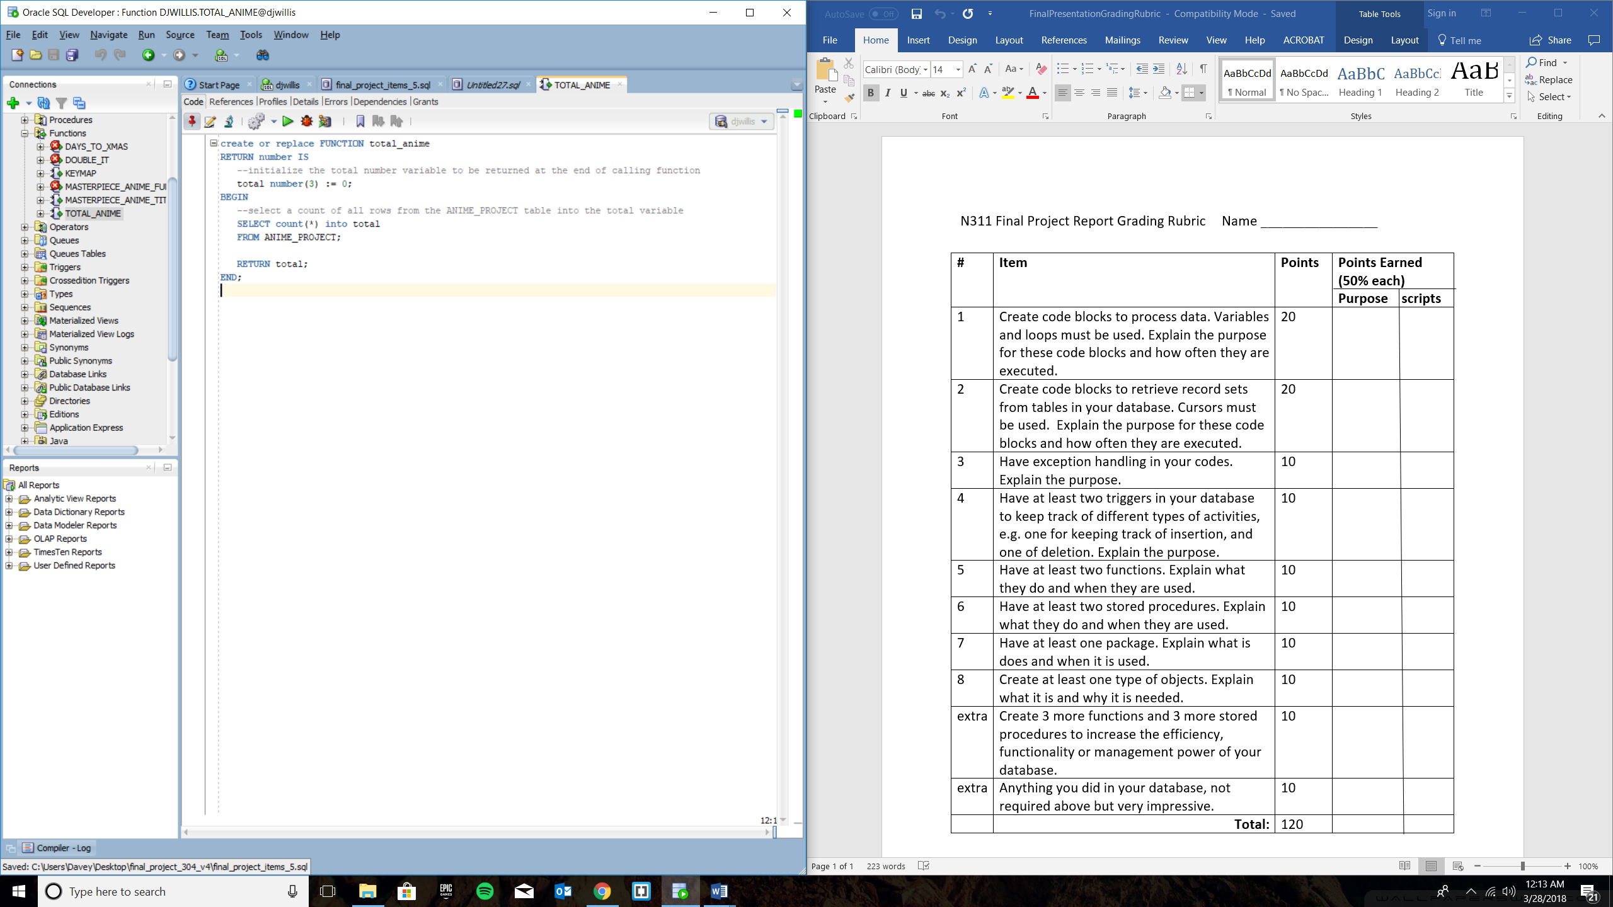

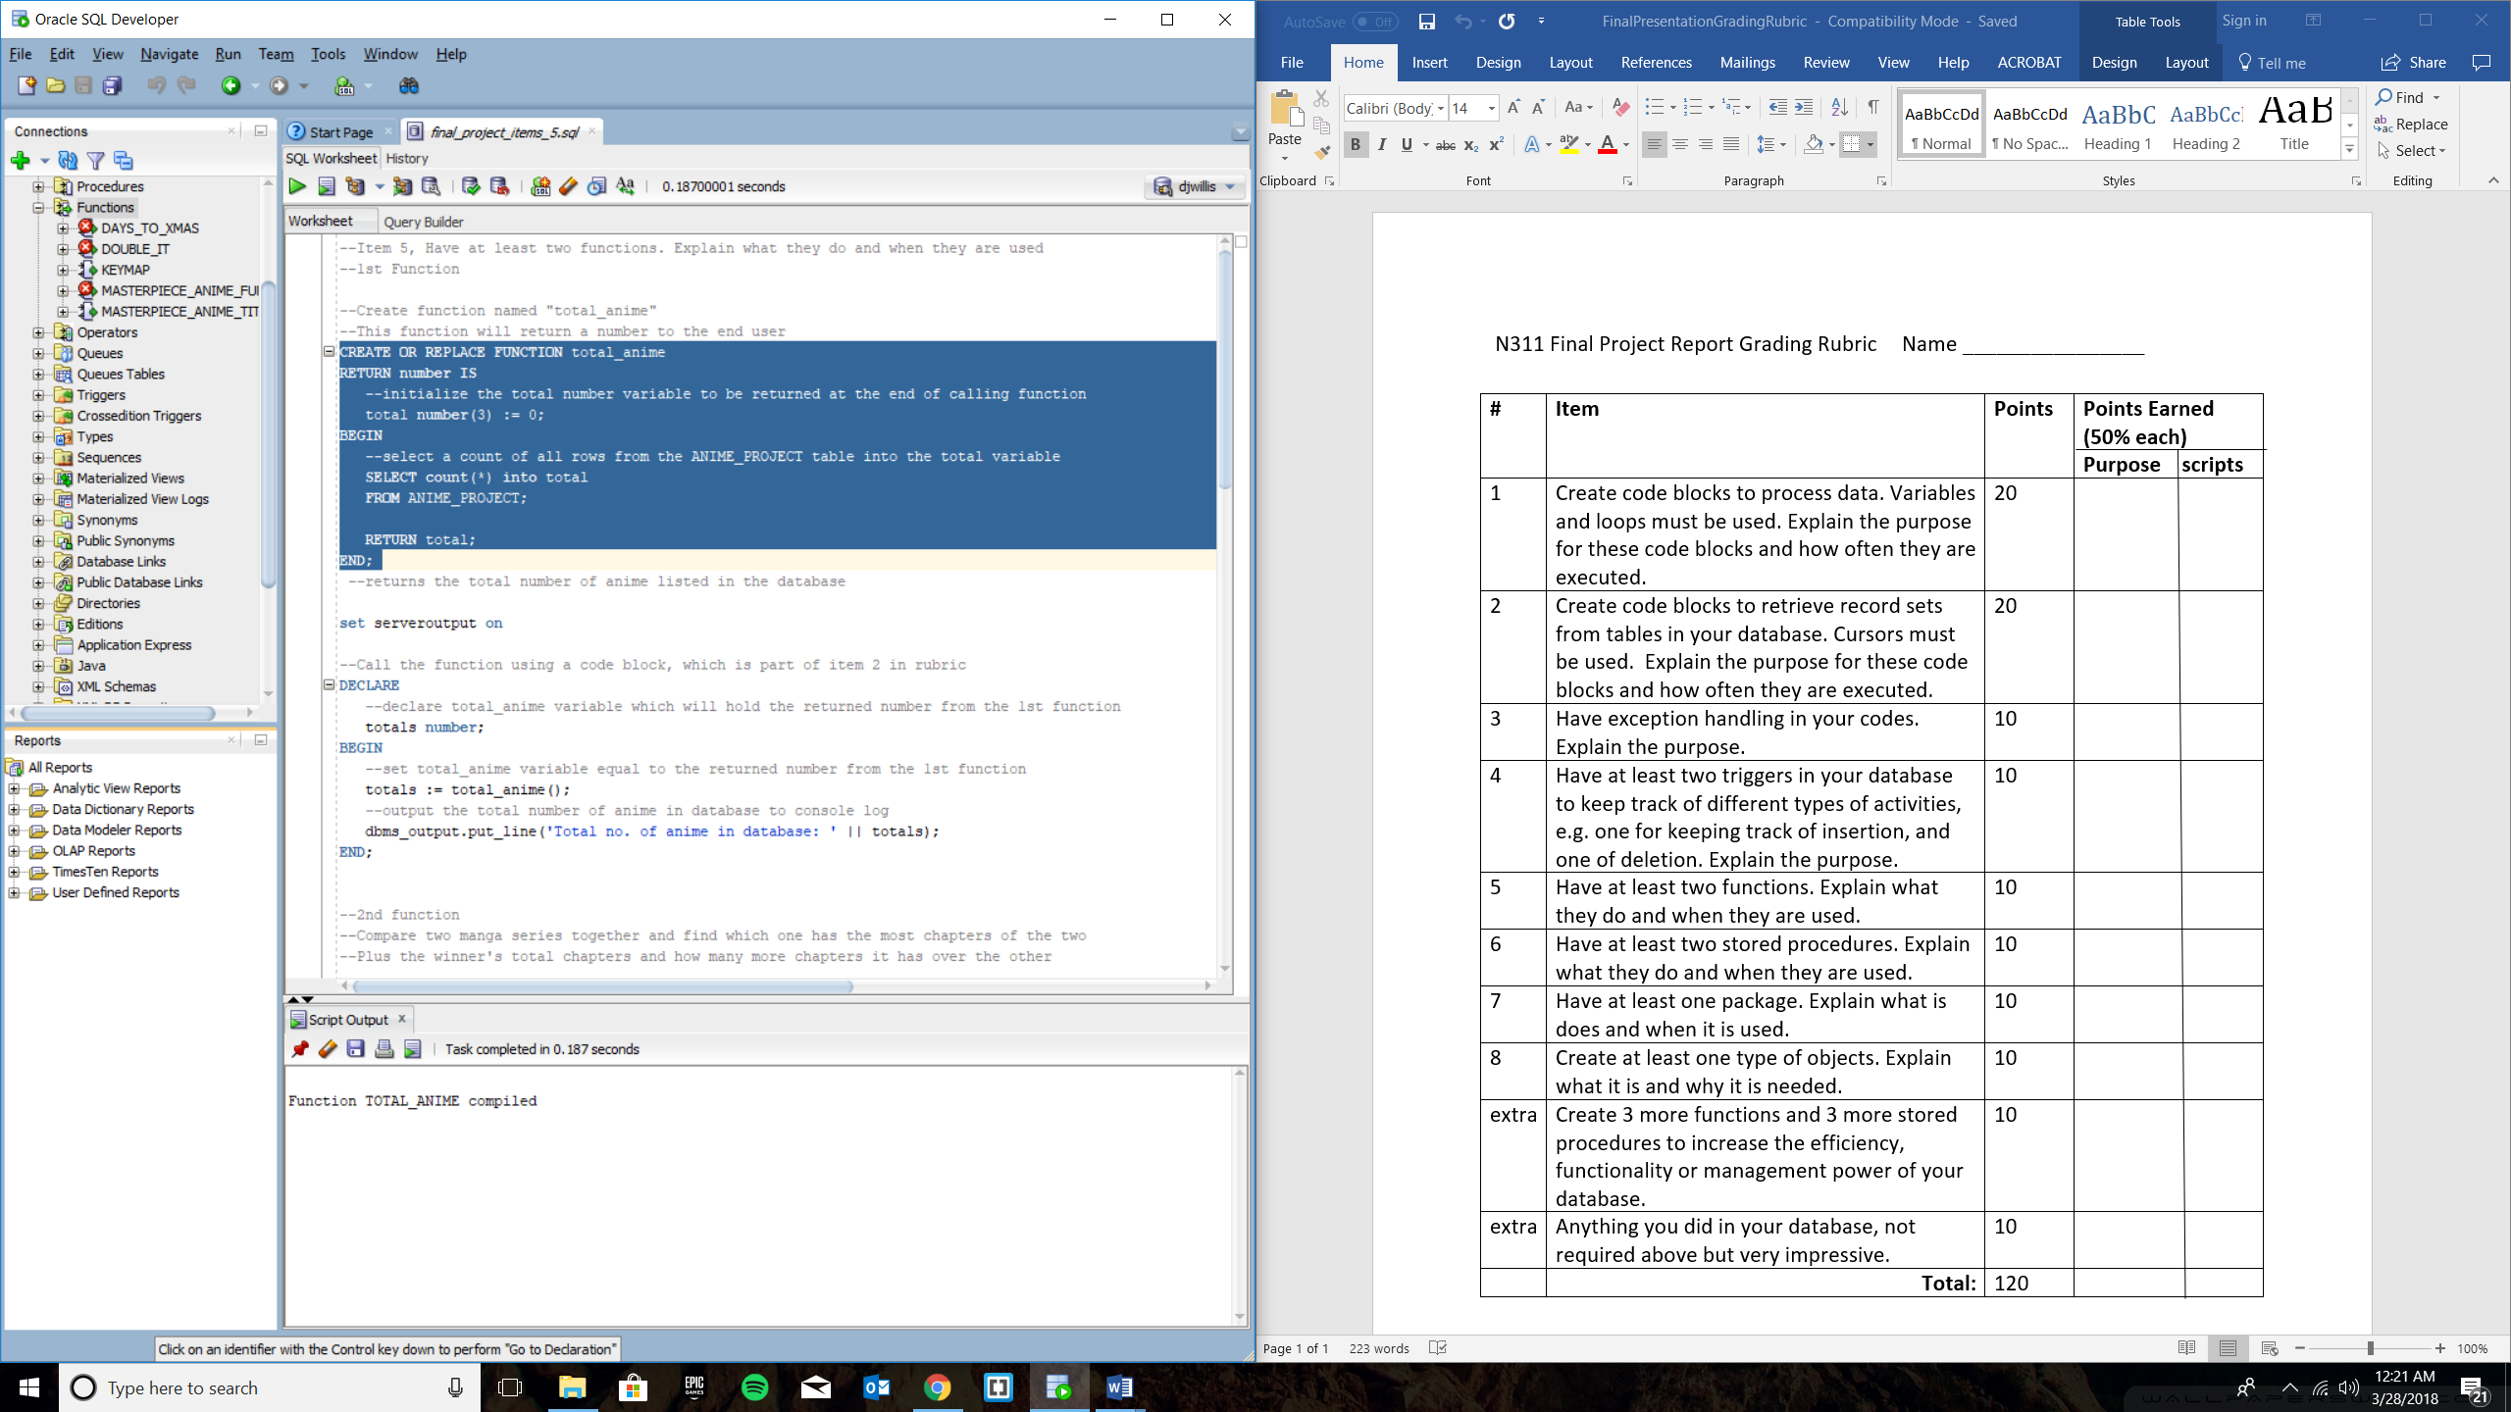

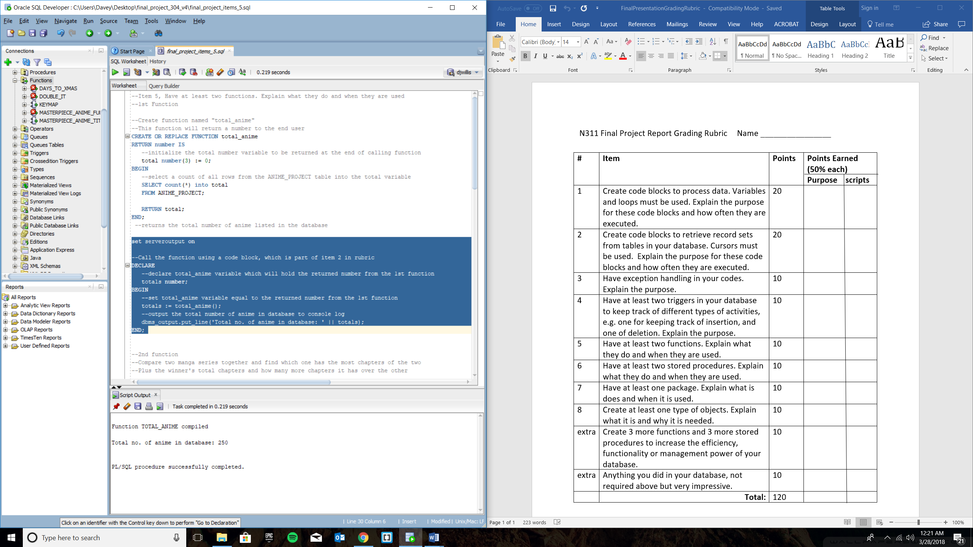

**findMax FUNCTION**

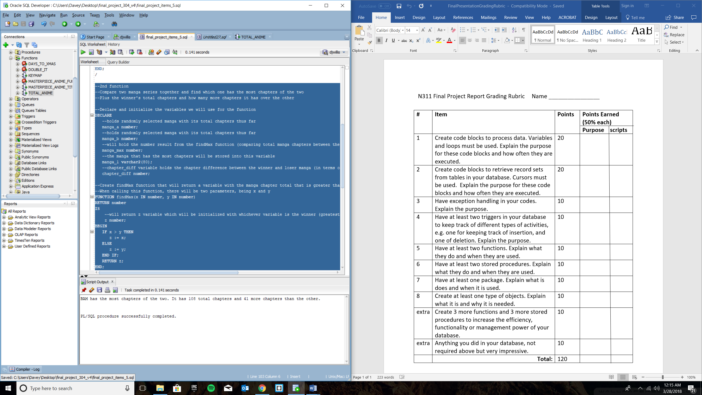

**Item 6**

**--Item 6, Have at least two stored procedures.**

**--Explain what they do and when they are used.**

**--1st procedure**

**--Create procedure named "SHONEN_JUMP", which will loop through SERIALIZATION_PROJECT**

**--table and find all rows of data in which the manga serialization company is**

**--named "Weekly Shonen Jump" and insert it into a cursor then output all of the found data**

**--to the console**

**--this command enables text to be outputted to the console**

**set serveroutput on;**

**--create procedure SHONEN_JUMP**

**CREATE OR REPLACE PROCEDURE SHONEN_JUMP**

**AS**

**--references data types and data values from the SERIALIZATION_PROJECT table**

**shon_manga_id SERIALIZATION_PROJECT.manga_id%TYPE;**

**shon_serialized_by SERIALIZATION_PROJECT.serialized_by%TYPE;**

**shon_first_published SERIALIZATION_PROJECT.first_published%TYPE;**

**shon_last_published SERIALIZATION_PROJECT.last_published%TYPE;**

**--create cursor which will contain all rows in which the manga serialization company**

**--is named "Weekly Shonen Jump"**

**CURSOR c1 IS**

**SELECT manga_id, serialized_by, first_published, last_published**

**FROM SERIALIZATION_PROJECT**

**WHERE serialized_by = 'Weekly Shonen Jump';**

**--begin code block**

**BEGIN**

**--begin cursor**

**open c1;**

**--begin looping through the SERIALIZATION_PROJECT table**

**LOOP**

**--Fetch command will retrieve all of the columns of data from the rows**

**--with "Weekly Shonen Jump" as the serialized_by value and put it into the**

**--newly created variables for the c1 cursor**

**--will exit out of fetch statement if the "Weekly Shonen Jump" value is not found**

**FETCH c1 INTO shon_manga_id, shon_serialized_by, shon_first_published, shon_last_published;**

**EXIT WHEN c1%NOTFOUND;**

**--Output each data variable for each fetched row unto the console**

**DBMS_OUTPUT.PUT_LINE('Manga Id: ' || shon_manga_id);**

**DBMS_OUTPUT.PUT_LINE('Serialized By: ' || shon_serialized_by);**

**DBMS_OUTPUT.PUT_LINE('First Published: ' || shon_first_published);**

**DBMS_OUTPUT.PUT_LINE('Last Published: ' || shon_last_published);**

**DBMS_OUTPUT.PUT_LINE(' ');**

**--end loop statement**

**END LOOP;**

**--end cursor**

**close c1;**

**--end code block**

**END;**

**/**

**--2nd procedure**

**--Create procedure named "FAV_GENRES", which will loop through ANIME_PROJECT**

**--table and find all rows of data in which the main genre of that particular row is**

**--either 'Slice of Life' or 'Comedy' or 'Adventure'**

**--and insert it into a cursor then output all of the found data to the console**

**CREATE OR REPLACE PROCEDURE FAV_GENRES**

**AS**

**--references data types and data values from the ANIME_PROJECT table**

**fav_anime_id ANIME_PROJECT.anime_id%TYPE;**

**fav_title ANIME_PROJECT.title%TYPE;**

**fav_anime_status ANIME_PROJECT.anime_status%TYPE;**

**fav_main_genre ANIME_PROJECT.main_genre%TYPE;**

**fav_rating ANIME_PROJECT.rating%TYPE;**

**fav_manga_id ANIME_PROJECT.manga_id%TYPE;**

**--create cursor which will contain all rows in which the main genre of anime**

**--is classified as 'slice of life', 'comedy', or 'adventure'**

**CURSOR cur1 IS**

**SELECT anime_id, title, anime_status, main_genre, rating, manga_id**

**FROM ANIME_PROJECT**

**WHERE main_genre = 'Slice of Life' OR main_genre = 'Comedy' OR main_genre = 'Adventure';**

**--begin code block**

**BEGIN**

**--begin cursor**

**open cur1;**

**--begin looping through the ANIME_PROJECT table**

**LOOP**

**--Fetch command will retrieve all of the columns of data from the rows**

**--with main genre as 'slice of life', 'comedy', or 'adventure' and put it into the**

**--newly created variables for the cur1 cursor**

**--will exit out of fetch statement if one of the three specified values are not found**

**FETCH cur1 INTO fav_anime_id, fav_title, fav_anime_status, fav_main_genre, fav_rating, fav_manga_id;**

**EXIT WHEN cur1%NOTFOUND;**

**--Output each data variable for each fetched row unto the console**

**DBMS_OUTPUT.PUT_LINE('Anime Id: ' || fav_anime_id);**

**DBMS_OUTPUT.PUT_LINE('Title: ' || fav_title);**

**DBMS_OUTPUT.PUT_LINE('Anime Status: ' || fav_anime_status);**

**DBMS_OUTPUT.PUT_LINE('Main Genre: ' || fav_main_genre);**

**DBMS_OUTPUT.PUT_LINE('Rating: ' || fav_rating);**

**DBMS_OUTPUT.PUT_LINE('Manga ID: ' || fav_manga_id);**

**DBMS_OUTPUT.PUT_LINE(' ');**

**--end loop statement**

**END LOOP;**

**--end cursor statement**

**close cur1;**

**--end code block**

**END;**

**/**

**Proof Procedure “SHONEN_JUMP” Created**

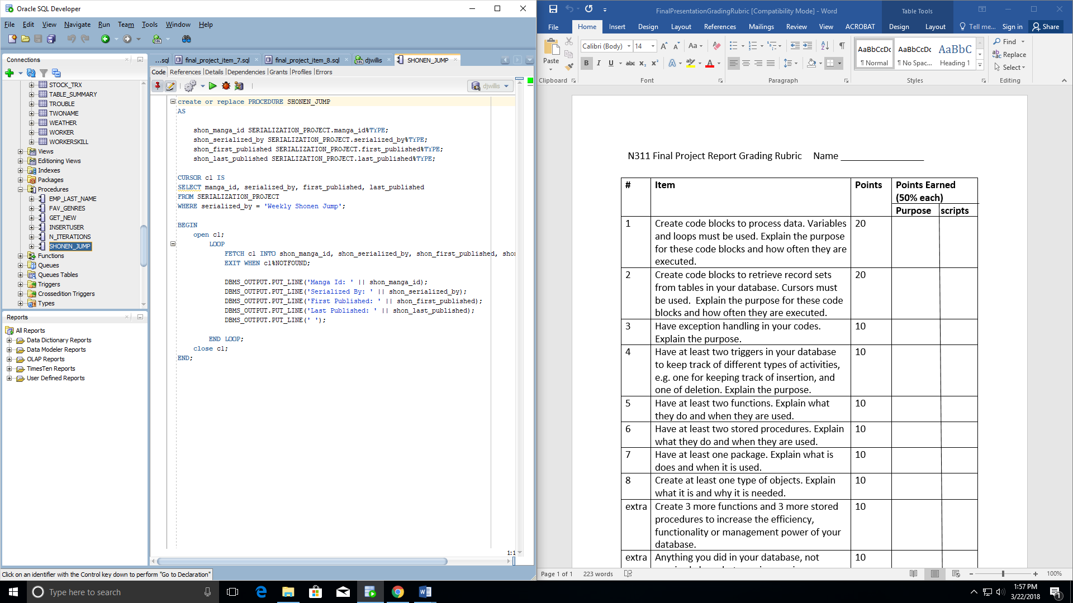

**Proof Procedure “FAV_GENRES” Created**

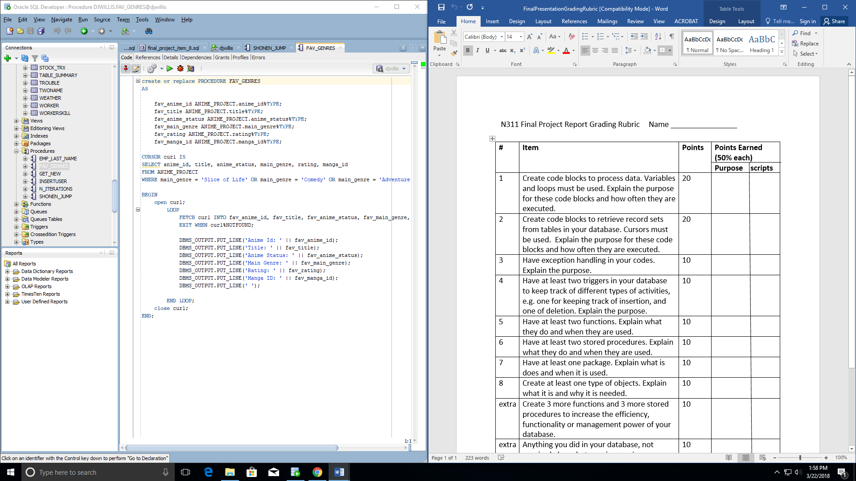

**Proof SHONEN_JUMP Procedure Works (via CALL FUNCTION)**

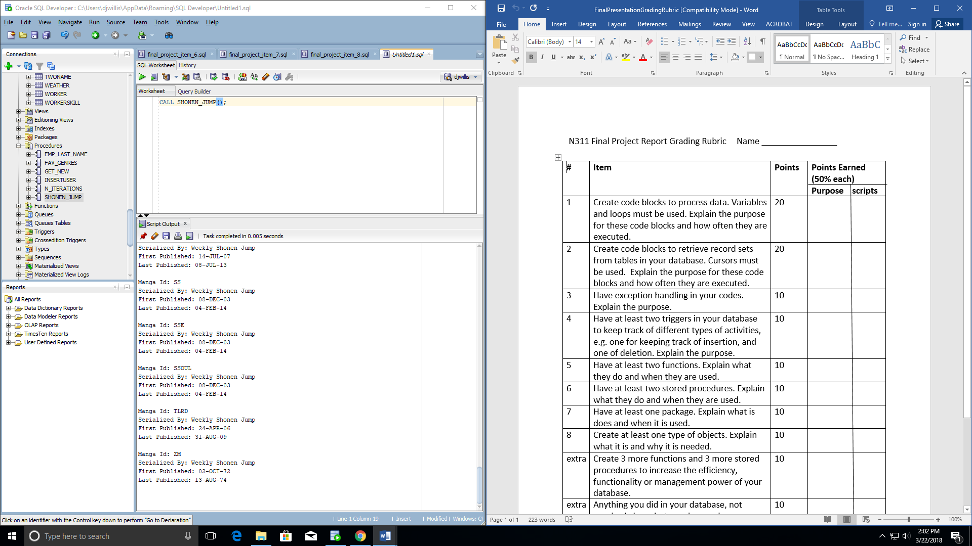

**Proof FAV_GENRES Procedure Works (via CALL FUNCTION)**

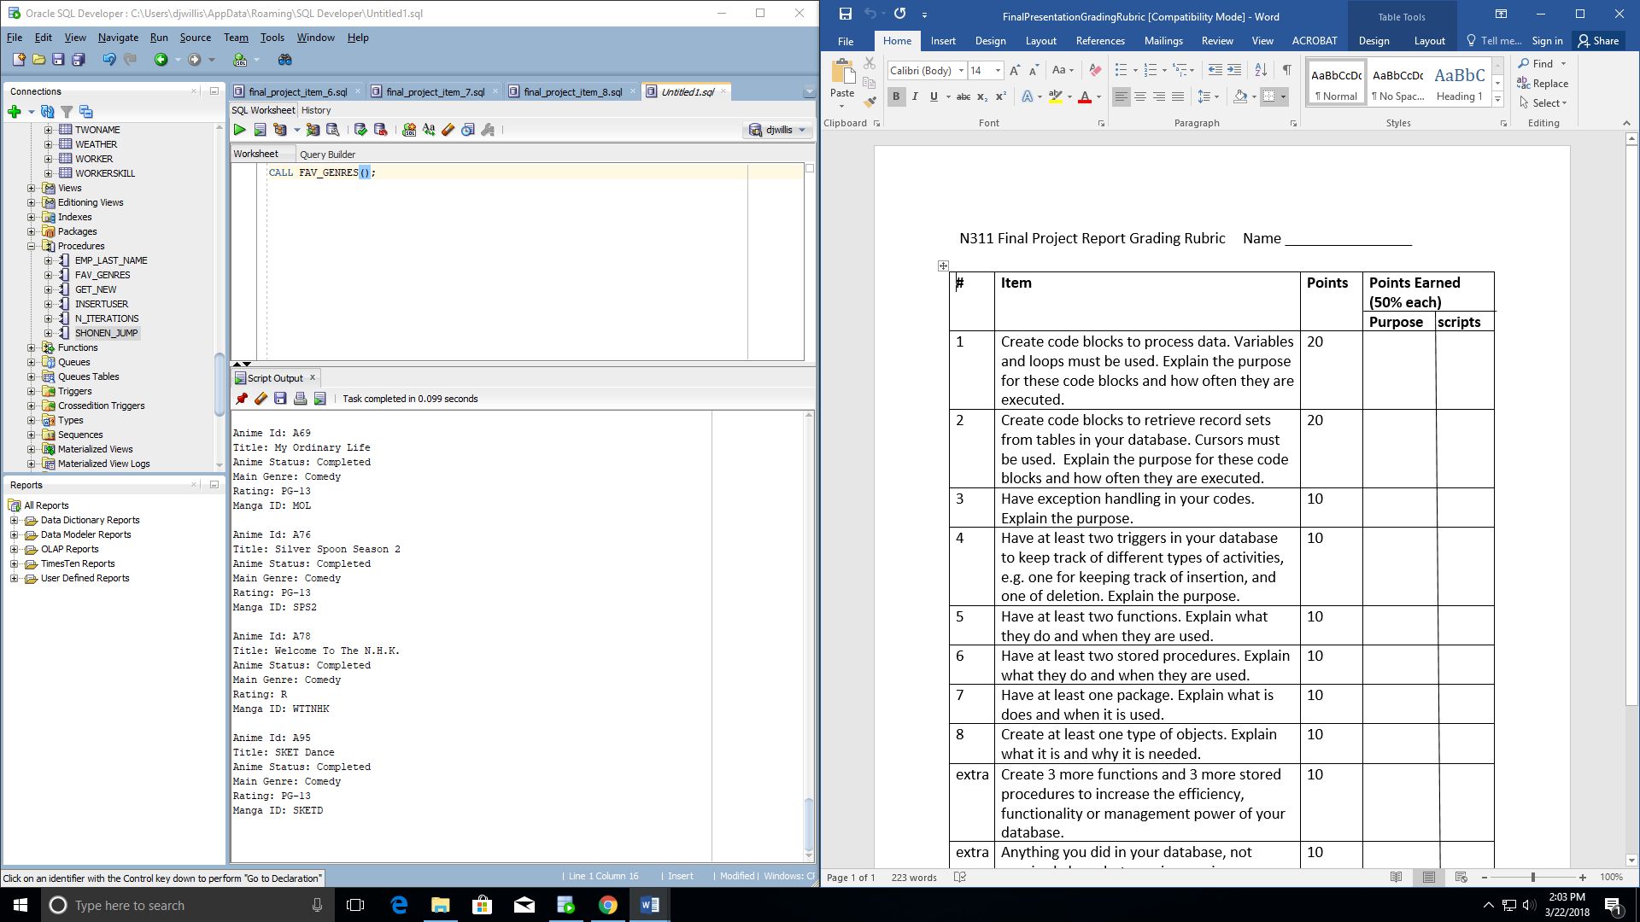

**Item 7**

**--Item 7, Have at least one package**

**--Explain what it does and when it is used**

**--this command enables text to be outputted to the console**

**SET SERVEROUTPUT ON;**

**--create package named "OVER_TWENTY_EPS", which will include the procedure "SHONEN_JUMP",**

**--which was used in item 6 to retrieve and output to the console all rows of data**

**--from the SERIALIZATION_PROJECT table in which the particular manga series was published**

**--by the 'Weekly Shonen Jump' publication**

**CREATE OR REPLACE PACKAGE OVER_TWENTY_EPS AS**

**PROCEDURE SHONEN_JUMP;**

**END OVER_TWENTY_EPS;**

**/**

**--this is the body of the previously created package containing the code to implement**

**CREATE OR REPLACE PACKAGE BODY OVER_TWENTY_EPS AS**

**PROCEDURE SHONEN_JUMP**

**AS**

**--references data types and data values from the SERIALIZATION_PROJECT table**

**shon_manga_id SERIALIZATION_PROJECT.manga_id%TYPE;**

**shon_serialized_by SERIALIZATION_PROJECT.serialized_by%TYPE;**

**shon_first_published SERIALIZATION_PROJECT.first_published%TYPE;**

**shon_last_published SERIALIZATION_PROJECT.last_published%TYPE;**

**--create cursor which will contain all rows in which the manga serialization company**

**--is named "Weekly Shonen Jump"**

**CURSOR c1 IS**

**SELECT manga_id, serialized_by, first_published, last_published**

**FROM SERIALIZATION_PROJECT**

**WHERE serialized_by = 'Weekly Shonen Jump';**

**--begin code block**

**BEGIN**

**--begin cursor**

**open c1;**

**--begin looping through the SERIALIZATION_PROJECT table**

**LOOP**

**--Fetch command will retrieve all of the columns of data from the rows**

**--with "Weekly Shonen Jump" as the serialized_by value and put it into the**

**--newly created variables for the c1 cursor**

**--will exit out of fetch statement if the "Weekly Shonen Jump" value is not found**

**FETCH c1 INTO shon_manga_id, shon_serialized_by, shon_first_published, shon_last_published;**

**EXIT WHEN c1%NOTFOUND;**

**--Output each data variable for each fetched row unto the console**

**DBMS_OUTPUT.PUT_LINE('Manga Id: ' || shon_manga_id);**

**DBMS_OUTPUT.PUT_LINE('Serialized By: ' || shon_serialized_by);**

**DBMS_OUTPUT.PUT_LINE('First Published: ' || shon_first_published);**

**DBMS_OUTPUT.PUT_LINE('Last Published: ' || shon_last_published);**

**DBMS_OUTPUT.PUT_LINE(' ');**

**--end loop statement**

**END LOOP;**

**--end cursor**

**close c1;**

**--end code block**

**END;**

**--end package body**

**END OVER_TWENTY_EPS;**

**Proof Package Was Successfully Created**

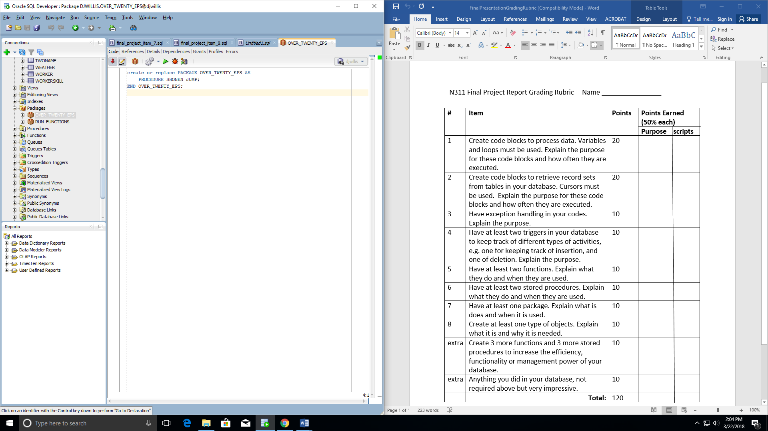

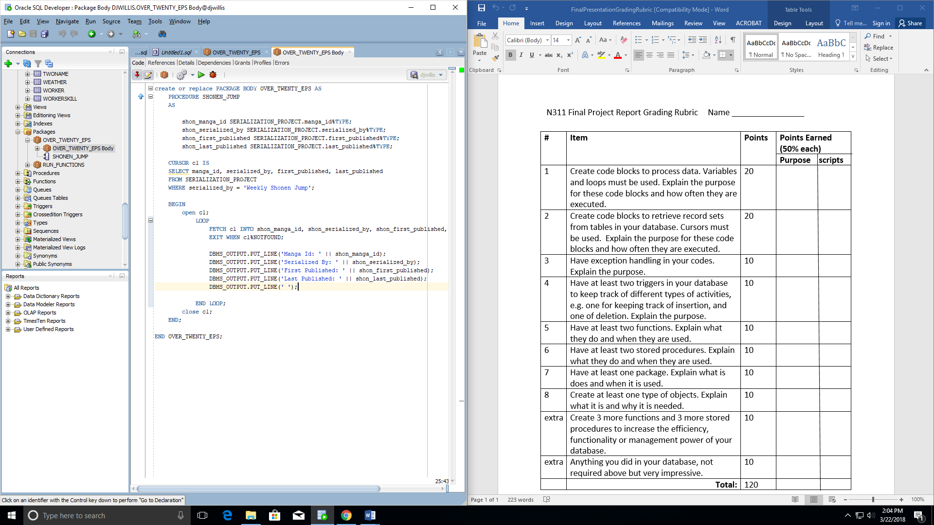

**Proof that the Package and embedded procedure work together (via EXEC command)**

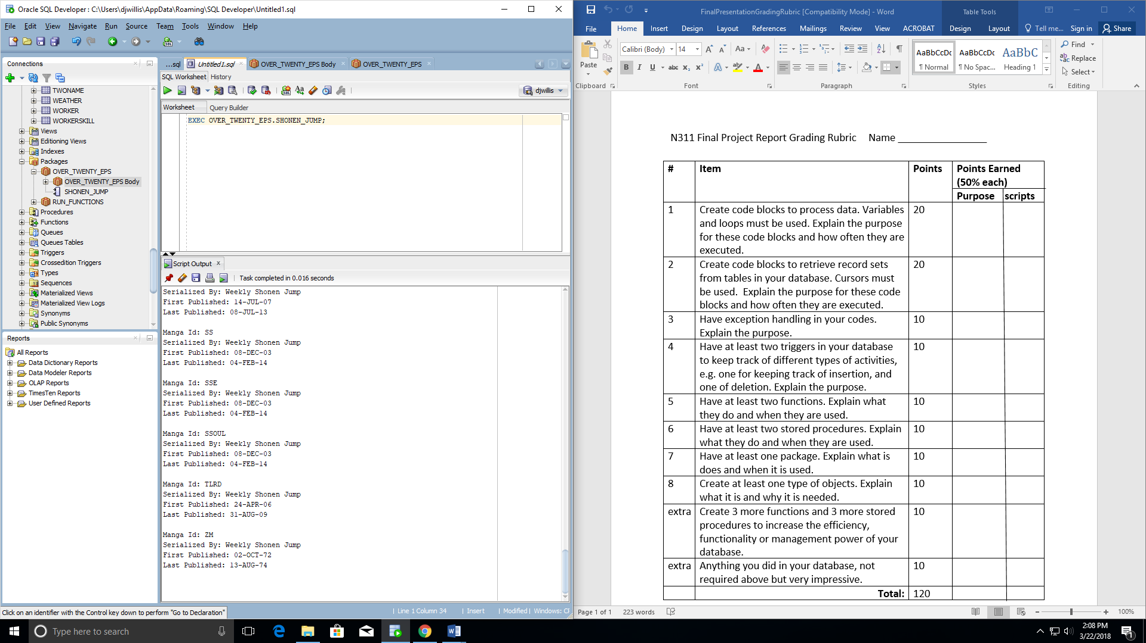

**Item 8**

**--Item 8, Create at least one type of objects**

**--Explain what it is and why it is needed**

**--Create object type named "new_anime_entry"**

**--The point of this object is to contain values for the anime_status, main_genre, rating, and manga_id**

**--variables which will be used to place new entries into the anime_entry table created below the object**

**--instead of listing 6 separate values to insert into a table, the object can be one data type to hold all**

**--of the data to be inputted**

**create or replace type new_anime_entry**

**as object**

**(**

**anime_status varchar2(40),**

**main_genre varchar2(40),**

**rating varchar2(10),**

**manga_id varchar2(10)**

**);**

**/**

**--Create table "anime_entry" to test the newly created object**

**--Initialize table with the anime_id, title, and the newly created object named "new_anime_entry"**

**--The variable name of the object will be called "new_entry"**

**create table anime_entry (**

**anime_id varchar2(10),**

**title varchar2(80),**

**new_entry new_anime_entry**

**);**

**desc anime_entry;**

**--For starters, we will insert the anime id and title of the anime along with the object that will**

**--contain the rest of the values to complete the table without any null columns**

**--to use the newly created object, all that is necessary is to use its object name and fill in the parantheses**

**--with the four bits of information needed to complete the entry**

**insert into anime_entry**

**values ('A001', 'Toradora', new_anime_entry('Completed', 'Slice of Life', 'PG-13', 'TDORA')**

**);**

**--add a second entry for the sake of proving this object works**

**insert into anime_entry**

**values ('A002', 'Darker Than Black', new_anime_entry('Completed', 'Action', 'R', 'DTB')**

**);**

**--begin code block created to prove that the above object and entries actually worked**

**DECLARE**

**--references data types and data values from the anime_entry table**

**v_anime_id anime_entry.anime_id%TYPE;**

**v_title anime_entry.title%TYPE;**

**v_new_entry new_anime_entry;**

**BEGIN**

**v_anime_id := 'A003';**

**v_title := 'K-On!';**

**--this newly created variable will be assigned the value of the object plus the data to be inputted via the object**

**v_new_entry := new_anime_entry ('Completed', 'Slice of Life', 'PG', 'KON'**

**);**

**--insert into the anime_entry table the newly created and assigned variables**

**insert into anime_entry (anime_id, title, new_entry) values (v_anime_id, v_title, v_new_entry);**

**--commit information to the database**

**commit;**

**--end code block**

**end;**

**/**

**--select all rows from anime_entry to output to console for proof all of the above statements worked**

**select * from anime_entry;**

**Proof that object exists and was created**

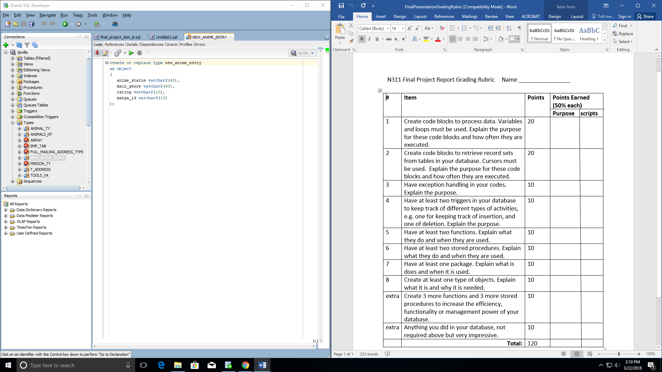

**Proof that object was successfully used and inserted into the ANIME_ENTRY table as the code describes:**

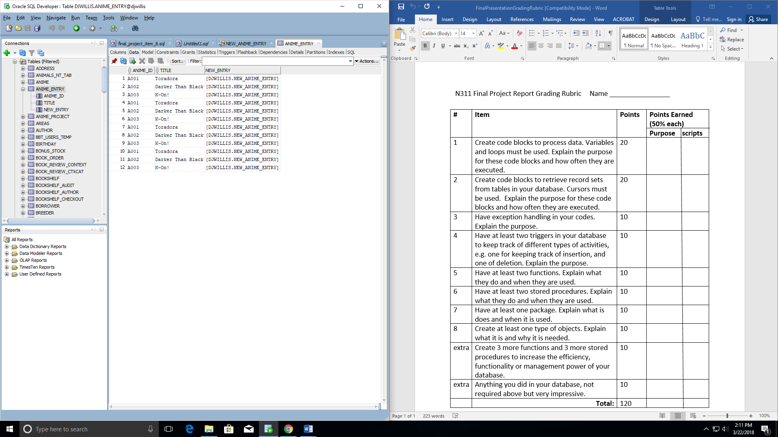

**Proof that we could continually use the object to add more data**

